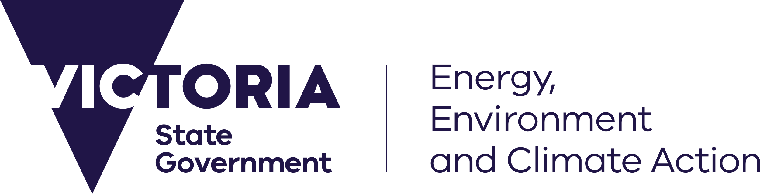

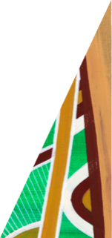

deeca.vic.gov.au

# Unmodelled futures and the Victorian Climate Projections 2024

The *Victorian Climate Projections* (VCP24) presents a plausible range of future Victorian climates based on scenarios of global greenhouse gas emissions and modelling of how the climate may respond to those scenarios. However, climate projections can never cover all future possibilities. This fact sheet outlines other possible climate outcomes and changes not modelled by VCP24, including ‘tipping points’ and relevant extreme climate hazards.

**Key messages**:

* VCP24 describes a range of possible future changes in Victoria’s climate but the projections do not represent all possible future climate changes for the state.
* Global tipping points are abrupt and irreversible changes to the global climate, triggered by global warming. Tipping points cannot be confidently modelled, but if triggered they would have important impacts on Victoria.
* Limitations of climate models mean that not all climate hazards can be confidently modelled, for example storms including wind and hail, megadroughts and compound events. 
* Decision-makers should use a risk management approach that considers high-impact, low likelihood risks to account for tipping points and unmodelled hazards.

## VCP24 does not describe all possible future climate changes for Victoria

**VCP24 provides a useful tool to explore changes in Victoria’s climate under low and high scenarios for future global emission of greenhouse gases. However, there are possible future climate changes that are not represented in the projections.**

In VCP24, future climate change is presented for two plausible greenhouse gas emissions scenarios representing a useful range of global emissions:

* SSP1-2.6, a low emissions scenario where global emissions are reduced rapidly, net zero is reached globally around 2075, and global warming is limited to 2 °C (the Paris Agreement goal).
* SSP3-7.0, a high emissions scenario where emissions roughly double present levels by 2100, resulting in large changes in climate.

VCP24 presents the likely range of change in Victoria’s climate under these emissions scenarios, but also includes some representations of changes outside the *likely* range, for example models showing a very hot, low-likelihood, high warming future.

However, it is important to acknowledge the possibility that there may be future changes which are not well represented in the VCP24 projections, with three main ways we could experience them:

* Through scenarios of anthropogenic emissions which are different to the two selected (such as an “overshoot” scenario where technology is used to rapidly drawdown greenhouse gases); or through major natural events such as large volcanic eruptions producing temporary climate effects.
* Large-scale climate responses that are outside the range of the typical changes we model – through abrupt changes such as ‘regime shifts’ in the climate system, and the reaching of ‘tipping points’ (see below); or global changes that are not yet well understood and represented in global climate models.
* Extreme events that remain hard to model and are not fully represented even in the latest cutting edge and high-resolution climate models. These include some types of severe wind and hail storms, megadroughts (that we know have occurred in the last few hundred years) and compound events.

Further detail is provided below on two areas of strong interest to decision-makers: tipping points and climate hazards not modelled in VCP24.

## Global climate tipping points are not accounted for in VCP24

**Global tipping points are relatively abrupt and effectively irreversible changes to global climate triggered by global warming. They are not included in the climate modelling considered by VCP24 but may have important impacts on Victoria.**

It is being increasingly acknowledged that major components of the Earth’s system are at risk of abruptly ‘tipping’ into a changed state in a rapid and self-perpetuating way that is irreversible on a long timescale. We know that tipping points have been triggered in the Earth’s past, and they can happen again. Examples include the rapid transition of Greenland and Antarctic ice sheets to a low ice state, the thawing of permafrost, and the shutdown of major ocean circulations that transfer heat and nutrients across the globe. There are also local-scale climate and ecological tipping points and regime changes that can occur, such as a change from woodland to grassland through frequent fires. Further global warming increases the risk of triggering tipping points, with different thresholds for different tipping elements.

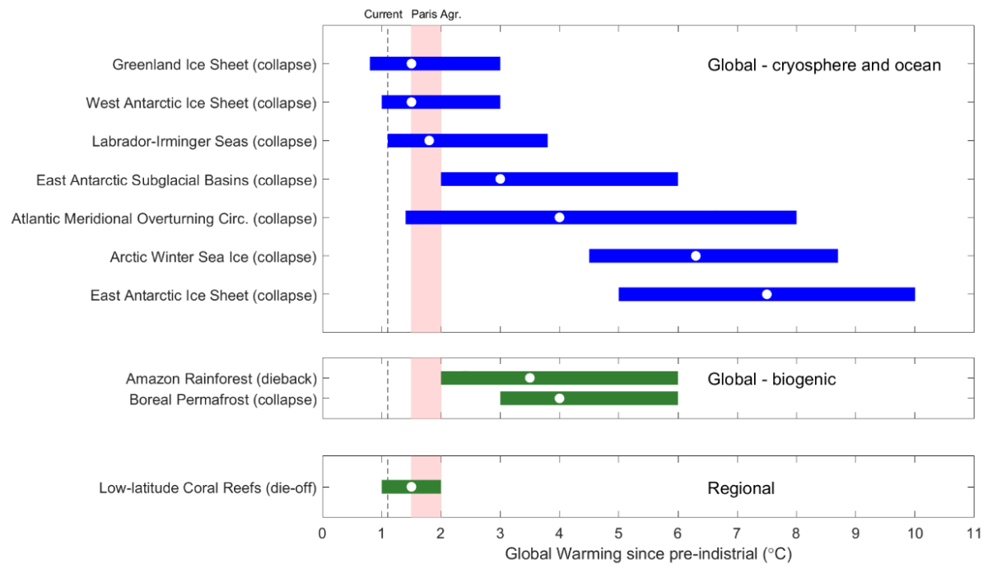

Figure 1. Nine global climate tipping points and one relevant regional tipping point listed in a recent global review. Horizontal bars show the review’s assessed ranges of global warming where the tipping may be triggered. Assessed ranges may differ from other studies. Source: CSIRO, 2024 (adapted from Armstrong McKay et al., 2022)

VCP24 projections acknowledge that abrupt climate changes and global climate tipping points changes can occur. However, the global and regional climate modelling used in VCP24 does not account for tipping points and no quantitative detail about when and how they could occur or what the effect would be is provided. This is because while we know that abrupt change can occur, considerable unknowns remain about how and when they might take place and the full dynamic effect they have.

The effects of triggering tipping points would be significant, but specific to how and when they are triggered. Therefore, rather than give explicit predictions or projections that are likely to be incorrect, we note abrupt changes as a possibility that cannot be ignored, especially for the higher warming scenario. This additional risk should be accounted for in addition to the risks identified through application of VCP24 projections (see below).

Different global climate tipping points would have different effects on Victoria. For example:

* A collapse of the Greenland or Antarctic ice sheets would lead to greater and more rapid sea level rise than in the reported range of *likely* change.
* Rapid permafrost thaw or Amazon dieback would produce enhanced global and regional warming, with some effect on Victoria.
* A shutdown or reversal of the Atlantic Meridional Overturning Circulation (AMOC)[1] would result in dramatic changes in the northern hemisphere climate but also possible changes to the average and extreme temperature and rainfall of Victoria, as well as other climate extremes.
* Indirect effects of major climate disruption in other places around the world would potentially flow on to Victoria in the form of disruptions to trade, supply chains, migration, conflict and other factors.

[Understanding the risks to Australia from global climate tipping points: Workshop report](https://www.csiro.au/en/news/All/Articles/2024/February/climate-tipping-points-Australia) (CSIRO, 2024), provides a more detailed summary of tipping points and their possible effect on Australia.

## Unmodelled climate hazards

**Not all climate hazards are confidently modelled in regional projections, including VCP24, due to limitations in representing the full set of relevant processes at all scales in computer models. These include storms and associated extreme winds and precipitation. Other risks not well accounted for in VCP24 may include very rare events such as megadroughts, or compound events where multiple hazards can occur together.**

Modelling storms is still limited due to many challenges in representing the full range of meteorological processes at all relevant spatial scales. To understand the effect of climate change on the extreme wind and precipitation (including rain and hail) from severe storms at an individual location, we need to understand change at a variety of scales, from large scale weather systems around the entire southern hemisphere through to the effect of local topography and more.

Given the challenges in modelling, we currently cannot confidently say if extreme winds will become more likely in the future in a warmer climate for Victoria or for any region within the state. So how should decision-makers account for these risks if extreme winds and storms pose a risk?

Even though we can’t be confident in the assessment of changes to storms or give quantitative projections, there is credible evidence that extreme storms of various types could very plausibly become more damaging with climate change. Given the damage and impact they cause, even without this plausible super-charge from climate change, a lower risk appetite decision-maker may decide to increase the resilience of systems that are particularly vulnerable to this hazard.

Very rare extreme events, such as megadroughts, are also not necessarily well represented in climate model simulations, even if we know they have occurred in the past and could occur again. For this risk, it is useful to consider evidence from the paleoclimate record,[2] and as with tipping points, to consider this as an additional risk overlain onto the risks explicitly implied in the projections.

The full effect of compound and consecutive extremes, including cascading impacts, is not directly explored in VCP24 projections. Compound extremes include ‘hot and dry’ events such as a hot drought setting up conditions ideal for fire, as well as ‘wet and windy’ events such as a coastal storm creating coastal and riverine flooding plus wind damage. These can create ‘cascading impacts’ across ecosystems, infrastructure and society.

### **Decision-makers can account for tipping points and unmodelled hazards**

**Decision-makers can account for tipping points and unmodelled hazards by taking a risk management approach that does not ignore high-impact, low-likelihood risks.**

The additional risk of unmodelled hazards should be accounted for in addition to the risks implied by the projections as part of good risk management.

Changes and events that are sometimes called High Impact, Low Likelihood risks (HILLs) cannot be ignored, and similarly we should not only plan for the worst. We must consider the full range of possibilities, the implications, and what can be done to mitigate the risks. The clearest case to mitigate the worst case or ‘tail’ risks is where the impacts are potentially very large, and the timeframe is very long.

More detail on using the VCP24 in planning for a changing climate can be found in [Factsheet 3 – Using the Victorian Climate Projections 2024](https://www.climatechange.vic.gov.au/victorias-changing-climate/VCSR24-Fact-Sheet-3-Using-VCP24.pdf) .



We acknowledge Victorian Traditional Owners and their Elders past and present as the original custodians of Victoria’s land and waters and commit to genuinely partnering with them and Victoria’s Aboriginal community to progress their aspirations.

The State of Victoria acknowledges the contribution of CSIRO, Australia’s national science agency, in producing this document. The information in this document is drawn from the Victorian Climate Projections 2024 Technical Report which should be consulted for more detail ([Round V, Grose M, Macadam I, Bodman R, King M, Truong S, Heady C, Thatcher M, Clarke J M (2024) Victorian Climate Projections 2024 Technical Report. CSIRO](https://www.climatechange.vic.gov.au/victorias-changing-climate/Victorian-Climate-Projections-2024-Technical-Report.pdf)).

Peer review support was provided by Dr Karl Braganza, Bureau of Meteorology

© The State of Victoria Department of Energy, Environment and Climate Action November 2024.

Creative Commons

This work is licensed under a Creative Commons Attribution 4.0 International licence, visit the [Creative Commons website](http://creativecommons.org/licenses/by/4.0/) (<http://creativecommons.org/licenses/by/4.0/>).

You are free to re-use the work under that licence, on the condition that you credit the State of Victoria as author. The licence does not apply to any images, photographs or branding, including the Victorian Coat of Arms, and the Victorian Government and Department logos.

ISBN 978-1-76136-389-4 **(pdf/online/MS word)**

Disclaimer

This publication may be of assistance to you but the State of Victoria and its employees do not guarantee that the publication is without flaw of any kind or is wholly appropriate for your particular purposes and therefore disclaims all liability for any error, loss or other consequence which may arise from you relying on any information in this publication.

Accessibility

To receive this document in an alternative format, phone the Customer Service Centre on 136 186, email [customer.service@delwp.vic.gov.au](mailto:customer.service@delwp.vic.gov.au), or contact National Relay Service on 133 677. Available at [DEECA website](http://www.deeca.vic.gov.au/) (www.deeca.vic.gov.au).

**References**

Armstrong McKay, D.I., Staal, A., Abrams, JF., Winkelmann, R., Sakschewski, B., Loriani, S., Fetzer, I., Cornell, S.E., Rockström, J., Lenton, T.M. (2022). [Exceeding 1.5 °C global warming could trigger multiple climate tipping points](https://doi.org/10.1126/science.abn7950). *Science, 377*(6611). https://doi.org/10.1126/science.abn7950.

CSIRO. (2024). [*Understanding the risks to Australia from global climate tipping points: Workshop report*.](https://www.csiro.au/en/news/All/Articles/2024/February/climate-tipping-points-Australia) https://www.csiro.au/en/news/All/Articles/2024/February/climate-tipping-points-Australia

**Other resources**

CSIRO. (2024). *Victorian Climate Projections 2024 Technical Report*. https://www.climatechange.vic.gov.au/victoriaschanging-climate/Victorian-climate-projections-2024- CSIRO.pdf

Department of Energy, Environment and Climate Action (DEECA) (2024). *Victoria’s Climate Science Report 2024*. https://www.climatechange.vic.gov.au/victorias-changing-climate#downloads

VCSR24 factsheets:

* [Factsheet 1 – How do the Victorian Climate Projections 2024 compare with previous climate projections for Victoria?](https://www.climatechange.vic.gov.au/victorias-changing-climate/VCSR24-Factsheet-1-Comparison-VCP24-and-VCP19.pdf)
* [Factsheet 2 – What do the Victorian Climate Projections 2024 say about changes in rainfall?](https://www.climatechange.vic.gov.au/victorias-changing-climate/VCSR24-Fact-sheet-2-Changes-in-rainfall.pdf)
* Factsheet 3 – Using the Victorian Climate Projections 2024

[Victoria’s Future Climate Tool](https://vicfutureclimatetool.indraweb.io/) – Victoria’s future climate projections can be explored using the tool.

1. AMOC refers to the system of ocean currents within the Atlantic Ocean.
2. The paleoclimate record includes information about the past climate from before instrumental measurements. For example, paleoclimate can be estimated using measurement from tree rings, sediments or ice cores.