**What do the Victorian Climate Projections 2024 say about changes in rainfall?**





[deeca.vic.gov.au](http://creativecommons.org/licenses/by/4.0/)

Ongoing changes in rainfall are likely to lead to significant impacts on Victoria. These changes could impact water resources, agriculture, flooding and bushfires in ways that could disrupt Victorian ecosystems, businesses and communities. This fact sheet helps users of the *Victorian Climate Projections 2024* (VCP24)[1],[2] understand what the projections say about changes in rainfall.

**Key messages**:

* Average annual rainfall and cool season rainfall in Victoria have been declining over the last 50 years and are likely to further decrease in the future, but rainfall will continue to vary from year-to-year and decade-to-decade.
* Dry periods in Victoria are projected to become drier and their impacts exacerbated by increases in temperature and evaporation.
* Heavy rainfall events in Victoria are likely to become more intense in the future.
* Future changes in summer rainfall in Victoria and regional patterns of rainfall change within Victoria are less clear.
* To address uncertainty in rainfall projections, decision-makers should consider multiple scenarios for future rainfall in Victoria and multiple lines of evidence when planning for changes in extreme rainfall.

## Victoria is likely to become drier, especially in the cool season

**Average annual rainfall and cool season rainfall in Victoria have been declining over the last 50 years.** **Average annual and cool season rainfall will likely continue to decrease in the future, but this long-term trend will be overlayed by year-to-year and decade-to-decade variability.**

Victoria’s rainfall varies greatly from year to year and decade to decade. However, underlying this variability, there has been a decline in average rainfall between 1961 and 1990 and more recent decades, especially in the cool (April to October) season. Cool season rainfall over Victoria has declined by around 13% between 1961-1990 and 2004-2023, and 9% since the commonly used 1986-2005 baseline. This is despite some relatively wet cool seasons since 2004.

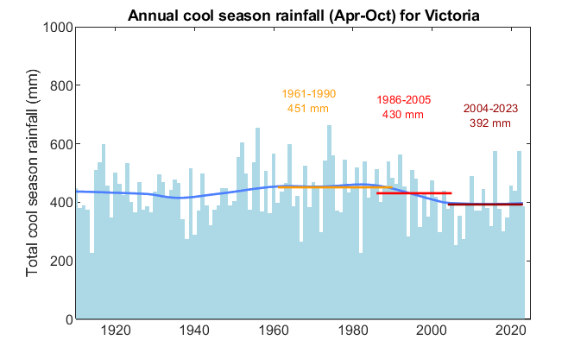

**Figure 1. Observed cool season rainfall for Victoria from 1910 to 2023.** The blue line shows the long-term trend. Average rainfall is also shown for 1961-1990, the 1986-2005 baseline used for the VCP19 and VCP24 projections and the most recent 20 years 2004-2023. Data sourced from the Australian Gridded Climate Dataset[3].

There is medium to high confidence that Victoria’s cool season rainfall will continue to decrease in the future. As well as the observed decline over the last 50 years, there is relatively high agreement on a future decline among the climate model simulations considered by VCP24 and previous simulations considered by the *Victorian Climate Projections 2019* (VCP19)[4]. This projection is also consistent with our understanding of the effects of climate change on reducing cold front and low-pressure systems over Victoria during the cool season, acquired through research initiatives such as the *Victorian Water and Climate Initiative*[5].

Confidence in long-term trends does not mean that rainfall will decrease consistently from year to year. Victoria’s rainfall will remain highly variable. This means that wet years and sequences of wet years will still occur even if there is a long-term drying trend. Although the cool season is likely to continue drying, periods where rainfall is similar to recent times or greater could still occur. Drying related to climate change will become more evident as the 21st century progresses, with larger changes occurring under high global emissions of greenhouse gases than under low emissions. Because most of Victoria’s annual rainfall occurs during the cool season, we also have confidence that annual rainfall will decline.

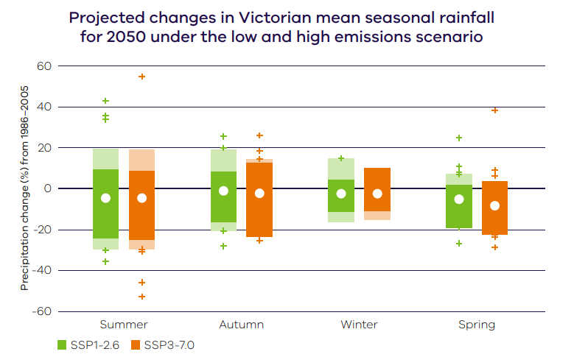

## Future changes in summer rainfall remain less clear

**There remains large uncertainty in projected changes in summer rainfall, with both decreases and increases possible. This is due to the large number of climate and weather drivers that influence summer rainfall.**

While we have some confidence in projected decreases in cool season and annual rainfall, there is large uncertainty in future changes to summer (December to February) rainfall. There has been no significant trend in average summer rainfall over Victoria, and potential changes are less clear than for cool season rainfall, with summer rainfall being sensitive to a broader range of climate and weather drivers than cool season rainfall.

VCP19 showed a large spread of results for future summer rainfall changes, including significant decreases and significant increases. The new modelling considered by VCP24 does not reduce this uncertainty. Some model simulations project an increase in year-to-year variability in summer rainfall, resulting in more extremely wet years and an increase in average summer rainfall. Other simulations project pronounced decreases in average summer rainfall. The range of uncertainty becomes larger under higher emissions and further into the future, as the climate deviates more from the known state. Research is under way to establish the level of confidence that should be assigned to the new model results.

**Figure 2. Projected changes in seasonal rainfall for Victoria for 2050 (2040–2059) for low (green) and high (orange) emissions scenarios, relative to a 1986-2005 baseline**. The dark coloured vertical bars show the 10th to 90th percentile range from CMIP6 Global Climate Model simulations. The lighter ‘extension’ shows the range from new regional model simulations. These ‘likely’ ranges encompass 80% of the model results and exclude model results which are in the top or bottom 10%. Individual regional model results outside the ranges are shown by the small crosses. The white circles show the medians of the global model results.

## Heavy rainfall events are expected to become more extreme

**Evidence suggests that heavy rainfall events will become more intense in the future.**

There is high confidence that heavy rainfall events will become more intense, even if the average total annual rainfall decreases. Scientific theory suggests that, overall, a warming of the atmosphere will make heavy rainfall events more intense. Consistent with this, there has been an observed trend towards more intense heavy rainfall in Victoria. Most model simulations considered by VCP19 and VCP24 project increases in intensity in the future. Generally, larger percentage increases in intensity are expected for rarer, more intense and shorter-duration rainfall events, a result supported by observations and climate model simulations. This includes extreme, short downbursts on the scale of minutes to hours, and extreme daily rainfall events, such as a 1-in-20 year rainfall event.

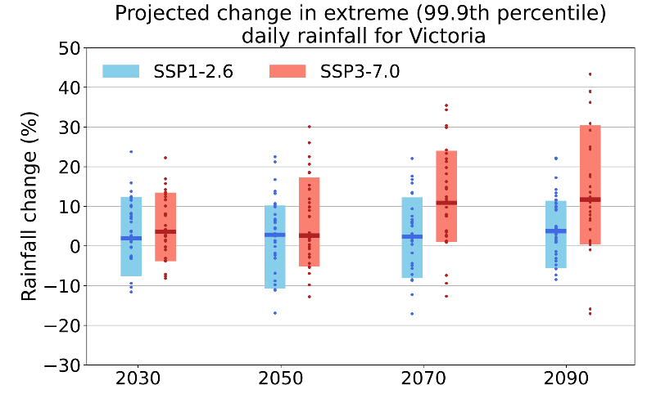

**Figure 3 Projected changes in rainfall on very heavy (99.9th percentile) rainfall days for Victoria for low (blue) and high (red) emissions scenarios, relative to a 1986-2005 baseline**. The vertical bars show the 10th to 90th percentile range from regional climate model simulations. This ‘likely’ range encompasses 80% of the model results and excludes model results which are in the top or bottom 10%. Small dots show the individual model simulations.

While future increases in the intensity of heavy rainfall are expected, VCP24 modelling shows a wide range of possible future changes in intensity (Figure 3). The highest resolution NARCliM2.0 modelling tends to show a minimal increase or a decrease in extreme daily rainfall in the future, particularly in summer. This is at odds with most of the other model simulations considered by VCP24 and other lines of evidence, including our understanding of the physics of extreme daily rainfall and observations. Assessing the plausibility of this result will require further research. In the meantime, planning for changes in heavy rainfall should be based on sources of information that consider multiple lines of evidence, such as the *Australian Rainfall and Runoff Guidelines[6]*.

## Detailed spatial patterns of future rainfall change within Victoria are unclear

**The high-resolution regional climate modelling considered by VCP24 provides detailed information about future rainfall changes across Victoria. However, statewide patterns of change are different between different simulations. Hence, how rainfall changes will differ between different parts of Victoria remains unclear.**

High-resolution regional climate modelling can represent spatial patterns in future rainfall change at levels of detail that global modelling cannot. However, the regional model simulations considered by VCP19 and VCP24 project a wide range of different spatial patterns of future rainfall changes for Victoria. For example, the ~5 km resolution CCAM modelling considered by VCP19 projected a decrease in rainfall on the western slopes of the Australian Alps in autumn, winter and spring compared to the surrounding regions, but this is not seen in the ~4 km NARCliM2.0 modelling considered by VCP24. Many of the differences in projected regional rainfall changes are due to the use of different regional climate models. More in depth analysis is being done by the Australian climate science community to understand these differences.

## Why are rainfall projections uncertain?

Projections of future rainfall are subject to significant uncertainty. Long-term trends in rainfall can be obscured by natural climate variability and rainfall is an inherently complex climate variable that is hard to simulate reliably in climate models.

Climate change, due to increasing amounts of greenhouse gases in the atmosphere, brings about changes to rainfall through two main processes:

* a warmer atmosphere can hold more moisture and cause overall global rainfall to increase
* changes in atmospheric circulation and weather systems can cause changes to the distribution of rainfall across the globe, and can lead to drying in some regions.

Victoria sits in the ‘mid-latitudes’, a zone generally projected to become drier globally under a warming climate and changing circulation patterns. However, changes in circulation and weather systems are complex and hard to simulate reliably in climate models and it is often not possible to say whether the rainfall of a particular region within the mid-latitudes will increase or decrease due to global warming. This is further complicated by the naturally large variability in rainfall at yearly and decadal time scales.

Rainfall changes can also be due to changes in the atmosphere other than those caused by the enhanced greenhouse effect. For example, aerosols from volcanic eruptions and human activity can affect regional rainfall. This adds further uncertainty to how rainfall may change in the future.

## Decision-makers should consider multiple scenarios for future rainfall

**Decision-makers should consider multiple scenarios for future rainfall in Victoria and use of sources of information that consider multiple lines of evidence when planning for extreme rainfall. They may also need to consider changes in other aspects of the climate that coincide with changes in rainfall, such as increasing temperatures or evaporation.**

Given the uncertainties in rainfall projections, decision-makers should consider multiple plausible scenarios or storylines for future rainfall in Victoria. These could range from a much drier climate to a wetter and much more variable climate. This approach is especially recommended for decisions affected by summer rainfall, for which VCP24 modelling shows a very wide range of future changes, including wetter and drier scenarios. Using multiple scenarios for future rainfall changes is consistent with the approach recommended for managing uncertainty in future changes in streamflow by the Victorian Water and Climate Initiative[7]. The Fact Sheet *Using the Victorian Climate Projections 2024*[8] provides more information about working with the uncertainties in VCP24.

Changes to heavy rainfall can be impactful in different ways to changes in average rainfall. Decision-makers should consult sources of information that consider multiple lines of evidence, such as the *Australian Rainfall and Runoff Guidelines[9]*. The Guidelines provide scaling factors that can be applied to recent heavy rainfall data to account for the effects of future climate change. Scaling factors are per °C of warming, with a higher value for sub-daily rainfall than daily rainfall. The Guidelines suggest that, broadly, across the whole of Australia, daily rainfall extremes may increase in intensity by approximately 8% per degree of warming while shorter sub-daily rainfall extremes may intensify by approximately 15% per degree of warming. VCP24 projections do not provide a compelling reason for decision-makers to depart from the Guidelines.

If drawing information directly from climate model simulations, decision-makers need to draw on multiple models with an understanding of what each model is representing in terms of extreme rainfall. Other lines of evidence should also be incorporated – a model which shows decreasing extreme rainfall is at odds with other lines of evidence and should be treated with caution.

To assess some climate change impacts, decision-makers also need to consider changes in other aspects of the climate and environment that are coincident with changes in rainfall. For example, projected increases in temperature and evaporation are expected to exacerbate the effects of deficiencies in rainfall on the overall availability of water in catchments during drought. The flood or erosion impact of an extreme rainfall event may be affected by changes to catchment soil or vegetation properties, and not just the nature of the extreme rainfall.

For further information on VCP24 rainfall projections, please see Chapter 3 of Victoria’s Climate Science Report 2024 and Chapter 4 of the Victoria’s Climate Projections 2024 Technical Report.



We acknowledge Victorian Traditional Owners and their Elders past and present as the original custodians of Victoria’s land and waters and commit to genuinely partnering with them and Victoria’s Aboriginal community to progress their aspirations.

The State of Victoria acknowledges the contribution of CSIRO, Australia’s national science agency, in producing this document. The information in this document is drawn from the Victorian Climate Projections 2024 Technical Report which should be consulted for more detail ([Round V, Grose M, Macadam I, Bodman R, King M, Truong S, Heady C, Thatcher M, Clarke J M (2024) Victorian Climate Projections 2024 Technical Report. CSIRO](https://www.climatechange.vic.gov.au/__data/assets/pdf_file/0031/726385/Victorian-climate-projections-2024-CSIRO.pdf)).

Peer review support was provided by Dr Karl Braganza, Bureau of Meteorology.

© The State of Victoria Department of Energy, Environment and Climate Action November 2024.

Creative Commons

This work is licensed under a Creative Commons Attribution 4.0 International licence, visit the [Creative Commons website](http://creativecommons.org/licenses/by/4.0/) ([http://creativecommons.org/licenses/by/4.0/](http://www.deeca.vic.gov.au/)).

You are free to re-use the work under that licence, on the condition that you credit the State of Victoria as author. The licence does not apply to any images, photographs or branding, including the Victorian Coat of Arms, and the Victorian Government and Department logos.

ISBN 978-1-76136-384-9 (pdf/online/MS word)

Disclaimer

This publication may be of assistance to you but the State of Victoria and its employees do not guarantee that the publication is without flaw of any kind or is wholly appropriate for your particular purposes and therefore disclaims all liability for any error, loss or other consequence which may arise from you relying on any information in this publication.

Accessibility

To receive this document in an alternative format, phone the Customer Service Centre on 136 186, email customer.service@delwp.vic.gov.au, or contact National Relay Service on 133 677. Available at [DEECA website](mailto:customer.service@delwp.vic.gov.au) (www.deeca.vic.gov.au).

1. [Victoria’s Climate Science Report 2024](https://www.climatechange.vic.gov.au/__data/assets/pdf_file/0028/726391/Victorias-Climate-Science-Report-2024.pdf)
2. [Victorian Climate Projections 2024 Technical Report](https://www.climatechange.vic.gov.au/__data/assets/pdf_file/0031/726385/Victorian-climate-projections-2024-CSIRO.pdf)
3. <http://www.bom.gov.au/climate/austmaps/about-agcd-maps.shtml>
4. [Victorian Climate Projections 2019 Technical Report](https://www.climatechange.vic.gov.au/victorias-changing-climate/Vic-Climate-Projections-2019-Technical-Report_1.pdf)
5. https://www.water.vic.gov.au/our-programs/climate-change-and-victorias-water-sector/hydrology-and-climate-science-research/victorian-water-and-climate-initiative
6. [Draft update to Climate Change Considerations chapter AR&R](https://storage.googleapis.com/files-au-climate/climate-au/p/prj2aec7b7ec59ab390bffc6/public_assets/Draft%20update%20to%20the%20Climate%20Change%20Considerations%20chapter.pdf)
7. [Victorian Water and Climate Initiative](https://www.water.vic.gov.au/our-programs/climate-change-and-victorias-water-sector/hydrology-and-climate-science-research/victorian-water-and-climate-initiative)
8. [Using the Victorian Climate Projections 2024](https://www.climatechange.vic.gov.au/victorias-changing-climate/VCSR24-Fact-Sheet-3-Using-VCP24.pdf)
9. [Draft update to Climate Change Considerations chapter AR&R](https://storage.googleapis.com/files-au-climate/climate-au/p/prj2aec7b7ec59ab390bffc6/public_assets/Draft%20update%20to%20the%20Climate%20Change%20Considerations%20chapter.pdf)