Victorian Greenhouse  
Gas Emissions Report 2022

Table of Contents

Acknowledgements 2

Minister’s foreword 4

Introduction 6

Victoria’s greenhouse gas emissions 6

Where do Victoria’s emissions come from 9

How have Victoria’s emissions changed 14

Updates to the way emissions are calculated 15

Abbreviations and acronyms 18

Source of data 19

# Acknowledgements

We acknowledge and respect Victorian Traditional Owners as the original custodians of Victoria’s land and waters, their unique ability to care for Country and deep spiritual connection to it.

We honour Elders past and present whose knowledge and wisdom has ensured the continuation of culture and traditional practices.

DEECA is committed to genuinely partnering with Victorian Traditional Owners and Victoria’s Aboriginal community to progress their aspirations.

© The State of Victoria Department of Energy, Environment and Climate Action 2024

**Creative Commons**

This work is licensed under a Creative Commons Attribution 4.0 International licence, visit the [Creative Commons website](http://creativecommons.org/licenses/by/4.0/) (http://creativecommons.org/licenses/by/4.0/).

You are free to re-use the work under that licence, on the condition that you credit the State of Victoria as author. The licence does not apply to any images, photographs or branding, including the Victorian Coat of Arms, and the Victorian Government and Department logos.

**ISSN** 2652-8495 **(online PDF/Word)**   
**ISSN** 2652-8932 **(print)**

**Disclaimer**

This publication may be of assistance to you but the State of Victoria and its employees do not guarantee that the publication is without flaw of any kind or is wholly appropriate for your particular purposes and therefore disclaims all liability for any error, loss or other consequence which may arise from you relying on any information in this publication.

**Accessibility**

To receive this document in an alternative format, phone the Customer Service Centre on 136 186, email customer.service@delwp.vic.gov.au, or contact National Relay Service on 133 677. Available at DEECA website (www.deeca.vic.gov.au).

# Minister’s foreword

Climate change is a critical issue for Victoria and the world. The Victorian Government is taking strong and lasting climate action.

The Victorian Government has legislated ambitious emissions reduction targets on our path to net zero by 2045. Our targets are to reduce emissions by 28-33% below 2005 levels by 2025, 45-50% by 2030, and 75-80% by 2035. These world leading targets   
will see Victoria playing its part in global efforts to limit the adverse impacts of climate change.

The *Victorian Greenhouse Gas Emissions Report 2022* helps us track Victoria’s progress to these targets. This report shows that Victoria has reduced its net emissions by 31.3% below 2005 levels – within the range of our 2025 target.

The data in this report shows that emissions are falling, even while our economy and population are growing. This reflects the efforts of all Victorians to take climate action.

The transition of Victoria’s energy system towards renewable technologies has made a major contribution to our emissions reductions to date. Our continued progress towards emissions reduction targets is supported by our nation-leading Victorian Renewable Energy Targets. The targets are 65% renewable energy by 2030 and 95% by 2035. We have also set energy storage targets of 2.6 gigawatts by 2030, and 6.3 gigawatts of storage by 2035. The revival of the State Electricity Commission will put electricity back in the hands of Victorians and support these renewable energy and storage targets.

Reducing our dependence on fossil gas will help slash emissions and power bills. Going all-electric in a new home puts $1,000 per year back in the pockets of new-home owners, or over $2,200 per year for those that have solar installed. In December 2023, I released an updated version of the Gas Substitution Roadmap. The update focuses on helping households to make the transition to efficient all-electric homes.

We’ll continue to work hard to reduce emissions and support the transition to renewable energy.

I trust this report will help governments, businesses, and individuals. It will help them find opportunities and take action for a future with zero emissions.

**The Hon. Lily D’Ambrosio MP**

Minister for Climate Action

Minister for Energy and Resources

Minister for the State Electricity Commission

# Introduction

## Victoria’s greenhouse gas emissions

This report is the seventh in a series of annual emissions reports as required under *Victoria’s Climate Change Act 2017* (the Act). The report provides an overview of the state’s current emissions, including the most important sources and trends. It also covers revisions to historical data.

### Victoria has cut emissions by almost a third since 2005

Victoria’s greenhouse gas net emissions for 2022 were 84.7 Mt CO2-e. (Net emissions represent the difference between the greenhouse gases released into the atmosphere and those removed from it. To simplify comparisons across various greenhouse gases, they are expressed in terms of carbon dioxide equivalent (CO2-e), which indicates the amount of carbon dioxide that would cause the same amount of global warming over a 100-year period. This report covers financial years, with 2022 referring to the period from 1 July 2021 to 30 June 2022.) This is a 31.3% reduction in emissions from 2005 levels. This is within the 2025 target range of reducing Victoria’s emissions by 28-33% below 2005 levels.

From 2021 to 2022, total emissions for the state have increased by 5.4%.

Figure 1: Victoria’s total net emissions, 2005 to 2022

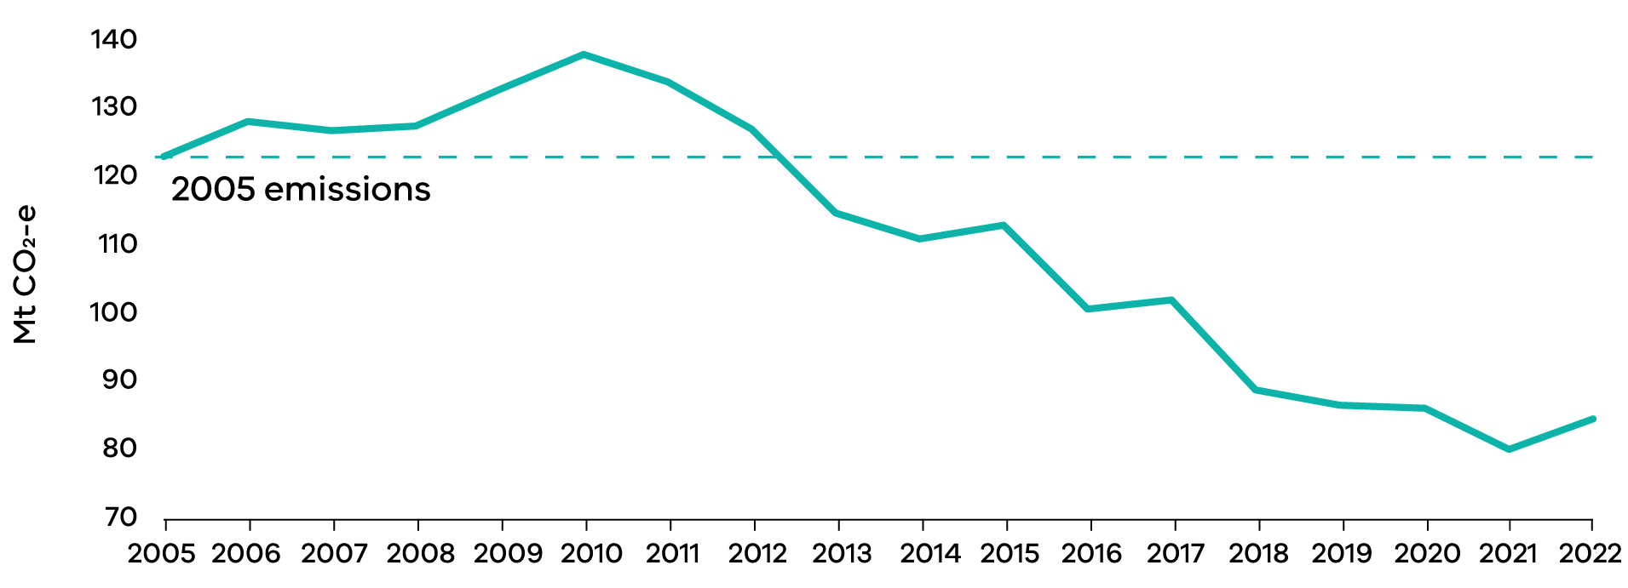

A major contribution to this is increased emissions from soil carbon compared to 2021. This is due to wetter than usual weather conditions. In wet conditions, microbes in the soil become more active and release more carbon dioxide. This increased overall Land Use, Land Use Change and Forestry (LULUCF) emissions.

A rebound of transport emissions as COVID-19 restrictions eased also contributed to the increase.

Things outside human control, such as weather, can have big impacts on emissions, especially in the LULUCF sector. To get a good sense of how our decisions and actions are impacting emissions, it is useful to look at the change in emissions excluding the LULUCF sector. Total emissions excluding LULUCF have decreased by 0.8% from 2021 to 2022 and have decreased every year since 2015.

### Victorians emit fewer greenhouse gases than the national average

Victoria’s emissions account for 19.6% of Australia’s national emissions. This makes Victoria the third largest state or territory contributor to national emissions.

Figure 2: Contribution to national emissions by state and territory, 2022

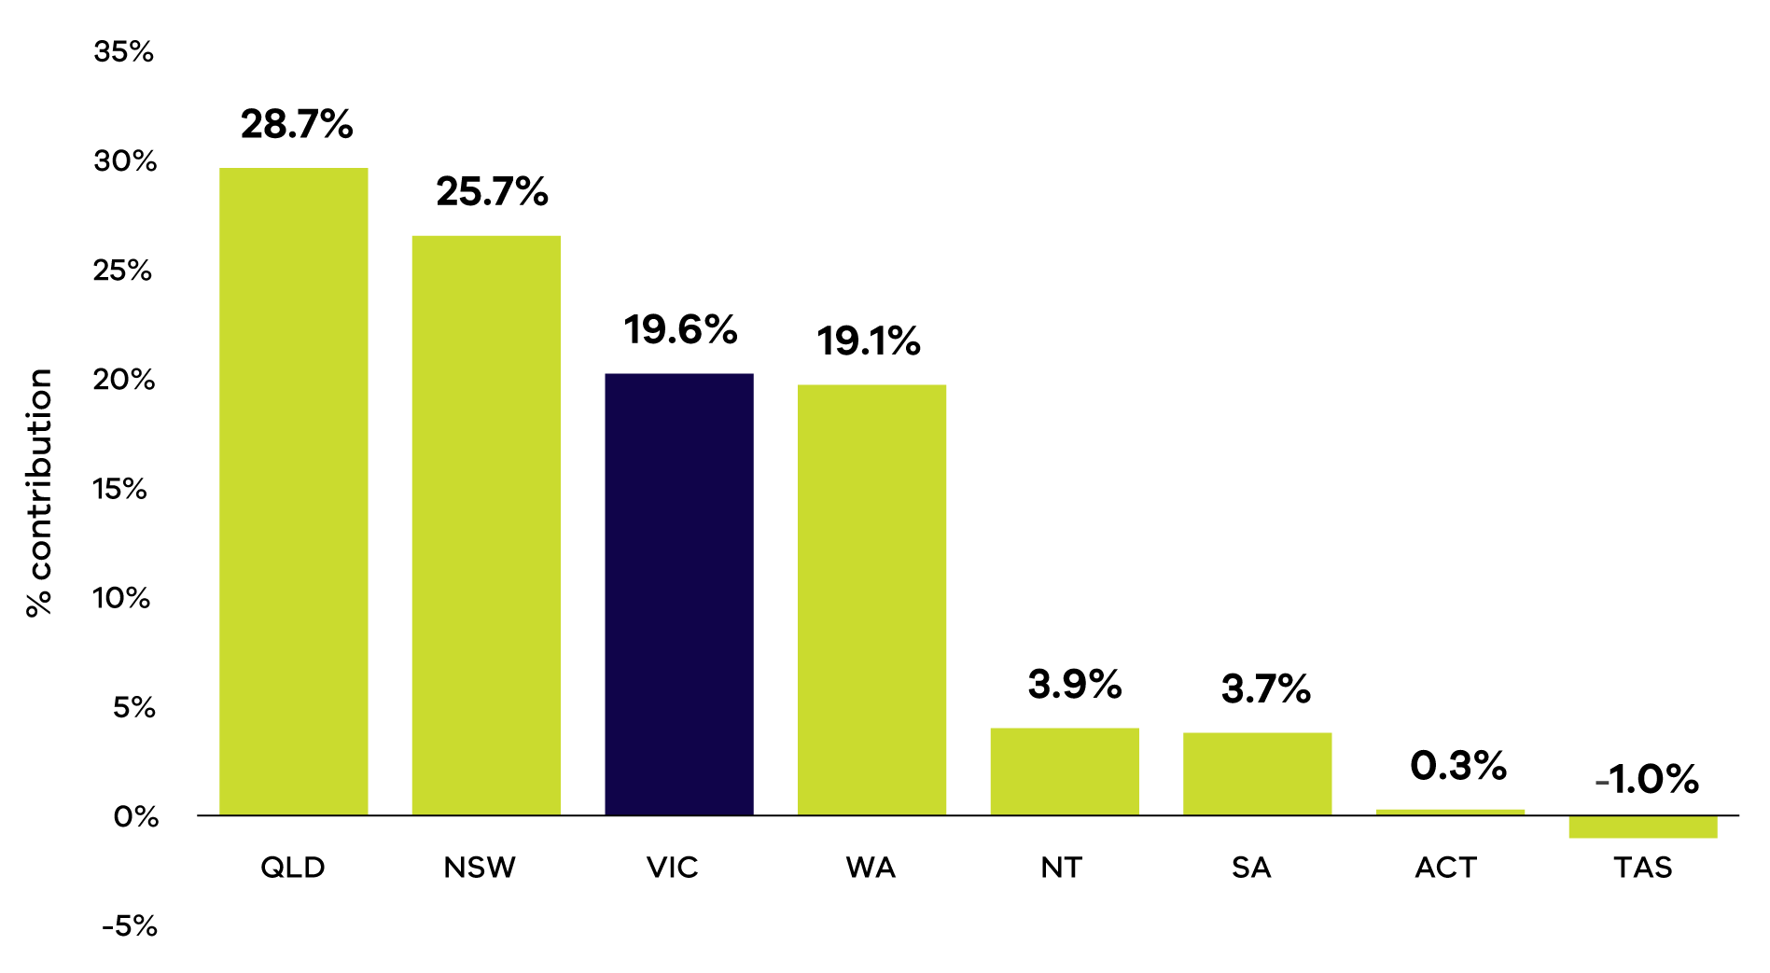

Victorians emit 12.8 tonnes of CO2-e per person on average. This places Victoria below the national average, and lower than all states and territories other than Tasmania, South Australia and the Australian Capital Territory. These states and territory have a higher use of renewable energy and produce less emissions from burning fossil fuels to make electricity. Tasmania also contains large forests that absorb carbon, resulting in their negative emissions.

Figure 3: Per capita emissions in Australia by state and territory, 2022

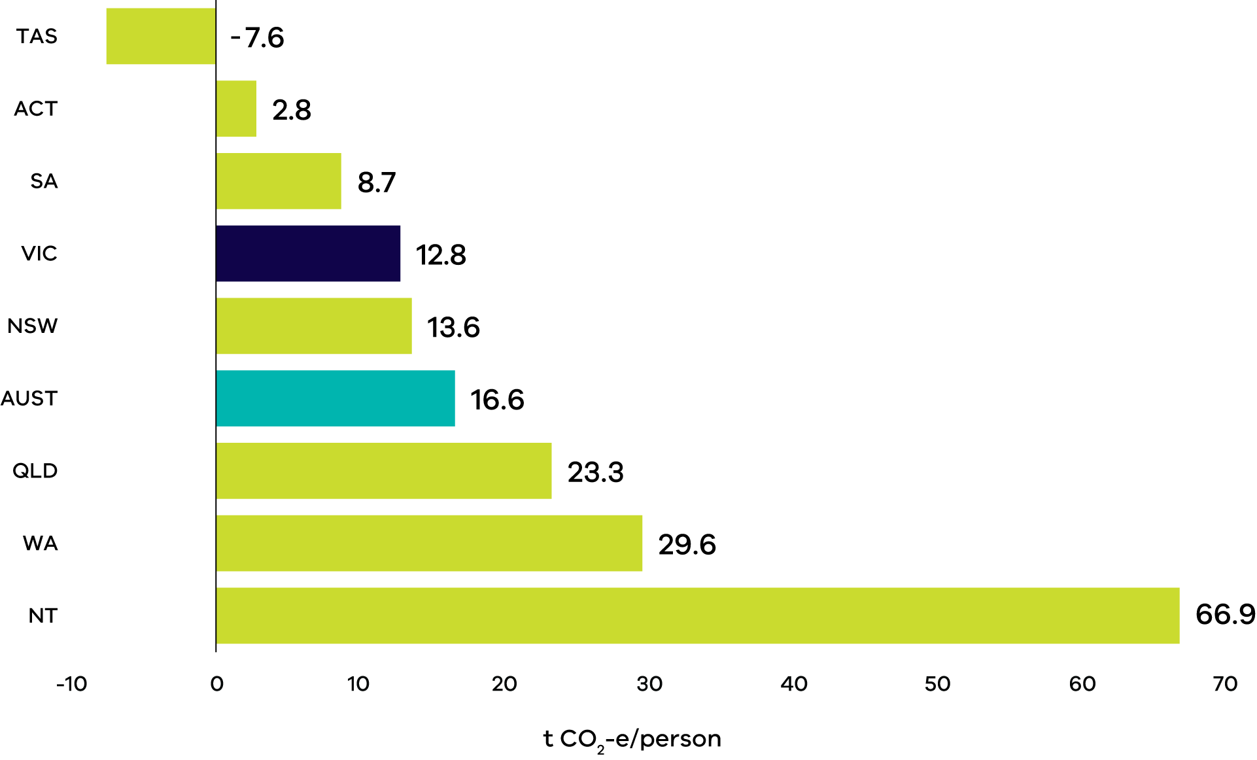

### Victoria’s population and economy are growing, yet emissions are falling

Victoria’s emissions have been trending down since 2010. Meanwhile, between 1990 and 2022, Gross State Product (GSP) has increased by 141% and the population has increased by 51% (GSP measures the value of goods and services produced in Victoria and is a metric that represents the size of Victoria’s economy). This shows that Victoria has continued to grow while reducing emissions.

The emissions intensity of the Victorian economy – measured as total net emissions divided by GSP – declinedby 68%, from 0.50 to 0.16 kg Victorians emit 12.8 tonnes of CO2-e per $GSP from 1990 to 2022.

Figure 4: Change in Gross State Product (GSP), population and emissions - Victoria, 1990 to 2022

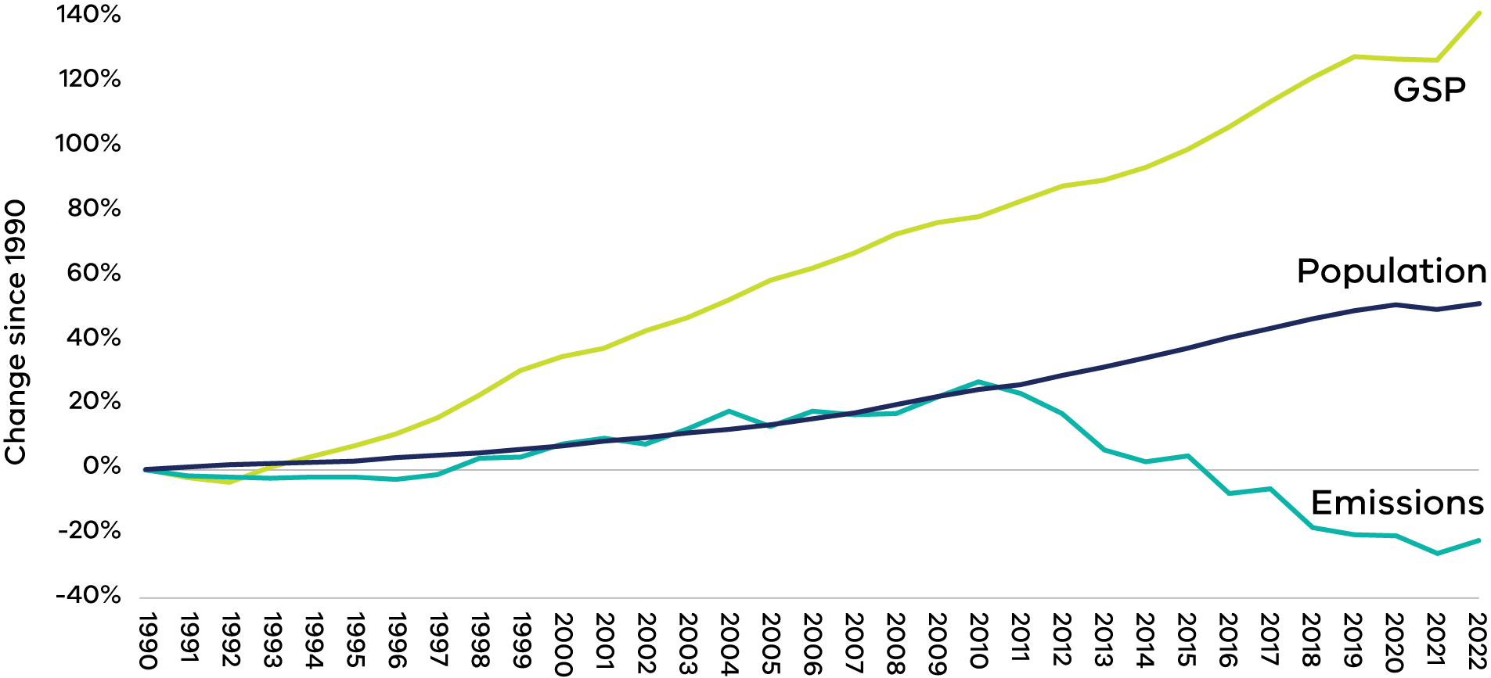

## Where do Victoria’s emissions come from

Figure 5: Victorian emissions by sector and energy subsector, 2022

(Sectors in this chart are as per the international standard categories determined by the Intergovernmental Panel on Climate Change (IPCC). They enable better comparison with other jurisdictions. They do not represent economic sectors. For example, fuels burned on farms count as fuel combustion not agriculture emissions).

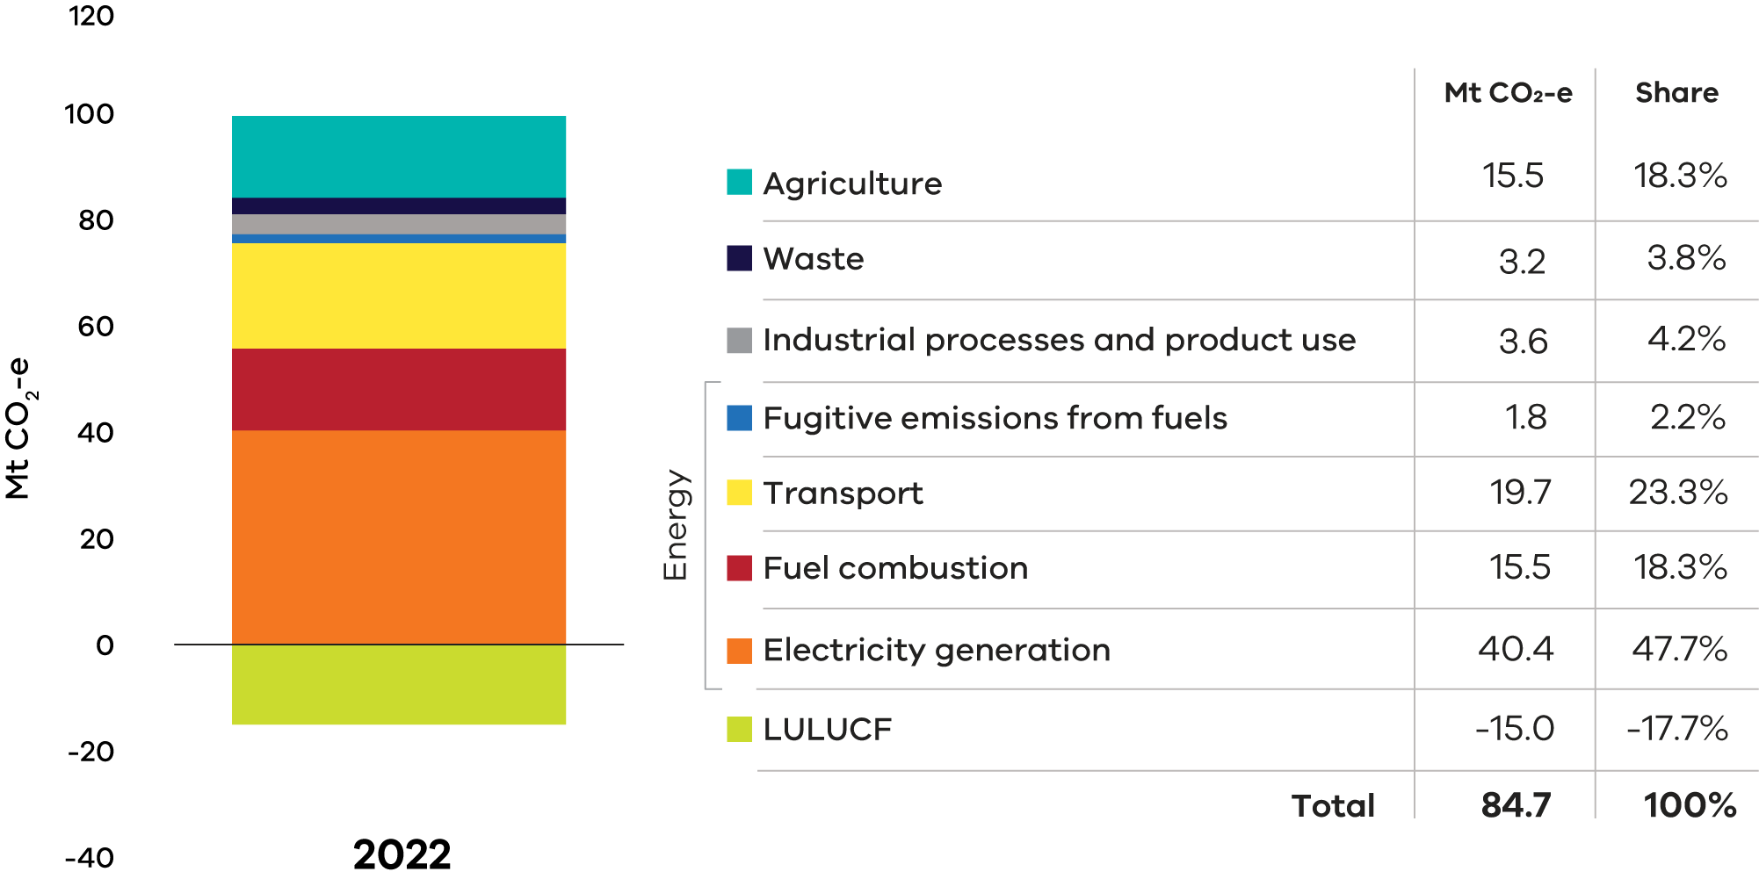**Note:** numbers may not sum to 100% due to rounding

More than 90% of Victoria’s greenhouse gas emissions come from burning fossil fuels to make energy. This energy is used for electricity, transport and fuel combustion. Electricity accounts for the majority of fossil fuel emissions – making up 48% of the state’s total emissions. The use of fossil fuels in cars, trucks and other transport contributes 23% of Victoria’s emissions. Burning fossil fuels in homes, businesses and industry contributes 18%.

Emissions from farming are the next most significant source of Victoria’s emissions, making up 18% of emissions. Industrial process and product use, referring to the release of human-made chemicals into the atmosphere, contribute to 4% of the state’s emissions. Emissions from waste, particularly methane released from landfills and wastewater treatment plants, are also responsible for 4% of emissions.

The LULUCF sector has reduced Victoria’s net emissions by 18% in 2022. This is because it accounts for trees and other plants, which absorb carbon dioxide as they grow.

#### Electricity

Electricity generation emissions are from the burning of fossil fuels to spin turbines that generate electricity. (Only those emissions generating activities that occur in Victoria are counted in the state’s emissions inventory. This means that the electricity sector accounts for emissions from electricity generation in Victoria, including any electricity that is exported to other states. Emissions from electricity that is imported to Victoria is not included in the state’s emissions.)

More than 95% of Victoria’s electricity emissions comes from burning brown coal. This happens at the three brown coal power plants: Loy Yang A, Loy Yang B and Yallourn located in the Latrobe Valley. A smaller amount of emissions comes from burning fossil gas to generate electricity. This happens in 8 major gas power plants located around Victoria.

Emissions from electricity generation made up almost half of Victoria’s net emissions in 2022.

#### Fuel combustion

Fossil fuels are burned for heating, hot water and cooking in homes and businesses. Industry burns fossil fuels to operate machinery or provide heat, steam, or pressure to manufacture goods. About a third of fuel combustion emissions come from homes.

The most common fuel burned is fossil gas, which accounts for 64% of fuel combustion emissions. Other common fuels in Victoria include diesel and LPG. Total emissions from fuel combustion contributed around a fifth of Victoria’s net emissions in 2022.

#### Transport

Transport emissions arise from the burning of fossil fuels in vehicles. (Electricity emissions from the use of electric vehicles (e.g. electric cars, trains, and trams) are counted in the electricity sector.) This includes cars, buses, vans, trucks, trains, aircraft, and watercraft. The most common fossil fuels used in transport in Victoria are petrol and diesel.

In 2022, transport made up almost a quarter of Victoria’s net emissions. About 90% of transport emissions came from road vehicles, of which 47% were from cars. This was followed by 23% from trucks and buses and 19% from vans. Air transport accounted for 6% of transport emissions.

#### Fugitive emissions from fuels

Fugitive emissions are the release or leaks of greenhouse gases, usually methane. This happens during the extraction, processing, and delivery of fossil fuels (including coal, oil, and fossil gas) to end users. Emissions from decommissioned coal mines are also included in this sector.

Fugitive emissions contributed 2% to Victoria’s net emissions in 2022. Almost all the emissions are from the extraction, processing, and distribution of fossil gas.

#### Industrial processes and product use (IPPU)

The chemical reactions in some industrial processes directly release greenhouse gases. These processes include the production of steel, cement, aluminium, and various chemicals.

Product use emissions are mainly from leaks of synthetic greenhouse gases. The most common synthetic gases are hydrofluorocarbons (HFCs) used in refrigeration and air conditioning.

In 2022, IPPU’s share of emissions was 4% of Victoria’s net emissions. Nearly 80% of these emissions came from leaks of HFCs from refrigeration and air conditioning equipment. The remaining emissions are from industrial processes.

#### Agriculture

Agriculture emissions arise from livestock and crop farming processes. Cows and sheep use gut microbes to help them digest their food. Some of these microbes release methane, a greenhouse gas. This process is called enteric fermentation and accounts for almost 70% of agriculture emissions in Victoria. Most of these enteric fermentation emissions come from cows.

Other sources of agriculture emissions in Victoria include the use of fertiliser in crop production and soil management practices. In 2022, agriculture contributed around a fifth of Victoria’s net emissions.

#### Land Use, Land Use Change and Forestry (LULUCF)

Vegetation and soil can emit carbon dioxide as well as absorb it from the atmosphere and store it. This is a process known as sequestration. If a carbon pool (a place that stores carbon) can absorb and store more carbon than it releases, then it is called a carbon sink. This means the LULUCF sector can function as both a source of emissions as well as a carbon sink depending on how land is used.

Planting more trees and encouraging plant life absorbs carbon emissions. This can be achieved through actions like starting a commercial plantation or doing environmental planting to improve biodiversity. Allowing previously grazed land to naturally regenerate increases sequestration too.

In 2022, sequestration in the LULUCF sector was equal to approximately a fifth of Victoria’s net emissions. Victoria’s forests provided by far the largest carbon sink within the sector of over 70% while over 20% of sequestration came from cropland and grassland.

#### Waste

Waste emissions are from solid waste decomposition in landfills and from the treatment of wastewater. When organic material breaks down in landfill it produces methane, a greenhouse gas. The treatment of wastewater to make it safe also releases methane and nitrous oxide, another greenhouse gas.

Waste emissions in 2022 contributed 4% to Victoria’s net emissions. 69% of the waste emissions were from solid waste disposal and 28% from wastewater treatment.

## How have Victoria’s emissions changed

Figure 6: Total net emissions and emissions by sector – Victoria, 1990 to 2022

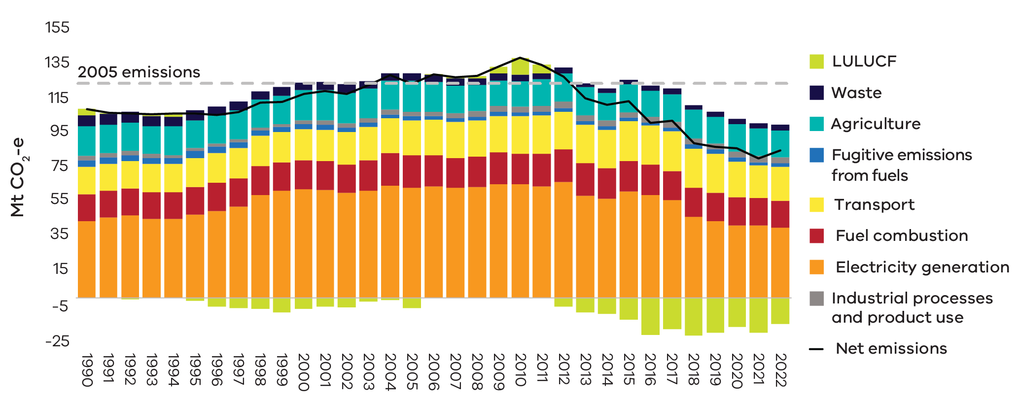

#### The transition to renewable energy continues to decarbonise electricity

In 2022, Victoria’s renewable energy generation reached 34% of electricity generation. ([Victorian Renewable Energy Target 2021/22 Progress Report](https://www.parliament.vic.gov.au/491b50/globalassets/tabled-paper-documents/tabled-paper-6812/vret_2021-22_progress_report_ptn9bzs8.pdf)). Meanwhile brown coal power plants have closed, with Hazelwood in 2017 and Anglesea in 2015. This has resulted in a 36% reduction of emissions since 2005 from the electricity sector. This is the largest reduction from any sector except LULUCF.

#### Industry has reduced its fossil fuel use

Fossil fuel combustion has decreased since 2005 by 16%. While residential fossil fuel use has increased as population grows, this has been counterbalanced by a reduction in fossil fuel used in manufacturing and fossil fuel production. This is primarily occurring in industry due to the reduction in energy intensive manufacturing in Victoria.

The extraction and production of fossil fuels have also decreased. This reduces fossil fuels use and results in declining fugitive emissions. Fugitive emissions have decreased by 21% since 2005.

#### Transport emissions have rebounded following COVID-19 restrictions

Transport emissions increased steadily from 1990 to 2015 by around 2% per year. During the pandemic in 2020 and 2021, there was a reduction of around 10% each year. In 2022, transport emissions rebounded, increasing by 6%. Whilst this is an increase, emissions in 2022 are still 13% lower than they were in 2019, before the pandemic.

#### Victoria’s forests are sequestering more carbon

The LULUCF sector was historically a source of emissions but has become a net sink since 2012. As native timber harvesting has reduced, previously logged areas have regenerated. The regrowth in trees has increased the sink from Victoria’s forests.

The growth of the plantation forest industry has also increased the sink from Victoria’s forests. Meanwhile, restrictions on land clearing have reduced emissions from the LULUCF sector.

As a result, emissions from LULUCF have changed from emitting 3% of Victoria’s emissions in 1990 to absorbing 18% in 2022. Short-term weather variation causes emissions in the sector to rise and fall around these long-term trends. Wetter than normal conditions cause microbes in the soil to become more active and release more carbon dioxide. The increase in LULUCF emissions from 2021 to 2022 is due to wetter than usual conditions.

## Updates to the way emissions are calculated

The Commonwealth Department of Climate Change, Energy, the Environment and Water (DCCEEW) makes improvements to emissions methods in response to new data, improved science, and review by international experts. The new methods are required to be used to recalculate old emissions data. These changes apply to all years from 1990 onwards. This means that method improvements can change Victoria’s emissions in 2005, which is the baseline year for Victoria’s interim emissions reduction targets.

This year’s recalculations have changed the State’s greenhouse gas emissions for the year 2005 from 118.2 Mt CO2-e to 123.2 Mt CO2-e, a 4.2% increase.

Figure 7: Changes in trends in Victoria’s total net emissions between 2005 and 2021 in the Victorian Greenhouse Gas Emissions Reports for 2021 and 2022

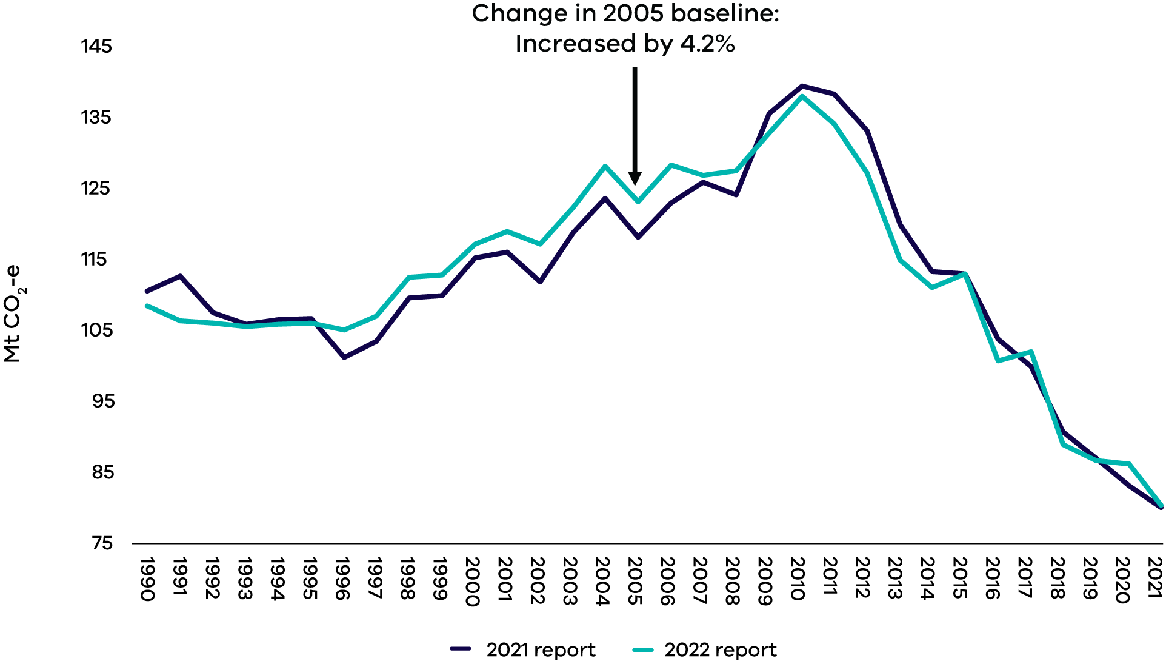

In their 2022 report, DCCEEW made some significant updates to the methods for calculating LULUCF sector emissions. One of the biggest changes was to the way soil carbon is modelled in cropland and grassland. Soil plays a significant role in the carbon cycle. It can be both a source and a sink for carbon, meaning it can both emit and sequester it. Weather conditions including temperature, rainfall, and evaporation, influence how this soil carbon cycle fluctuates.

The updates ensure that soil carbon modelling reflects this sensitivity. This has also required changes to how the data is averaged to ensure the modelled emissions best reflect human, not natural, influences. LULUCF emissions have changed significantly in most years, including in 2005.

A few changes in other sectors have occurred. Their impact is minor compared to the LULUCF changes. These include:

* updated historic data and model corrections for fugitive emissions from the fuels sector,
* updates to Australia’s official energy statistics which flow through to the inventory,
* updated 2021 activity data and improved estimates in the industrial processes sector,
* updated emissions factors for fertiliser use and crop residue in the agriculture sector.

A full list of changes can be found from page 445 of the National Inventory Report. ([National Inventory Report 2022](https://www.dcceew.gov.au/sites/default/files/documents/national-inventory-report-2022-volume-1.pdf))

# Abbreviations and acronyms

|  |  |
| --- | --- |
| Abbreviation | Definition |
| **ABS** | Australian Bureau of Statistics |
| **The Act** | Climate Change Act 2017 |
| **CH4** | Methane |
| **CO2-e** | Carbon dioxide equivalent |
| **DCCEEW** | Commonwealth Department of Climate Change, Energy, the Environment and Water |
| **DEECA** | Department of Environment, Energy and Climate Action |
| **GSP** | Gross State Product |
| **HFC** | Hydrofluorocarbons |
| **IPCC** | Intergovernmental Panel on Climate Change |
| **IPPU** | Industrial processes and product use |
| **LPG** | Liquefied petroleum gas |
| **LULUCF** | Land use, land use change and forestry |
| **Mt** | Million tonnes |
| **N2O** | Nitrous oxide |
| **PFC** | Perfluorocarbons |
| **SF6** | Sulphur hexafluoride |
| **STGGI** | State and Territory Greenhouse Gas Inventories |
| **UNFCCC** | United Nations Framework Convention on Climate Change |

# Source of data

Emissions data for the report are sourced from the State and Territory Greenhouse Gas Inventories (STGGI) released in April 2024 by DCCEEW. This provides data at a state and territory level over the period 1990 to 2022. These are the most recent official data on annual greenhouse gas emissions.

The data relate to emissions from goods and services produced in Victoria. This is under the United Nations Framework Convention on Climate Change (UNFCCC) emissions accounting provisions.

More detailed emissions data can be accessed at the DCCEEW website. ([Emissions reporting - DCCEEW](https://www.dcceew.gov.au/climate-change/emissions-reporting))

Economic and population statistics for Victoria were used to calculate emissions intensity measures. They are sourced from the Australian Bureau of Statistics (ABS). ([Population | Australian Bureau of Statistics and National accounts | Australian Bureau of Statistics](https://www.abs.gov.au/statistics/economy/national-accounts))

**End of document.**