Central Highlands Climate Projections 2024

Table of Contents

The climate of Central Highlands has already changed and will continue to change 1

About these projections 2

Central Highlands climate will continue to get warmer 4

Heat extremes in Central Highlands region will continue to become hotter and more frequent 7

Rainfall across Central Highlands region will continue to change 10

Extreme rainfall events are expected to intensify 13

Victoria is likely to experience fewer frosts 14

Victoria is likely to experience an increase in fire weather 15

Flooding patterns in Victoria are likely to change 15

Table of projected changes in key climate variables 16

Interpreting the projections figures 18

Publication information 21

# The climate of Central Highlands has already changed and will continue to change

Image 1: A map of Victoria showing the location of the Central Highlands

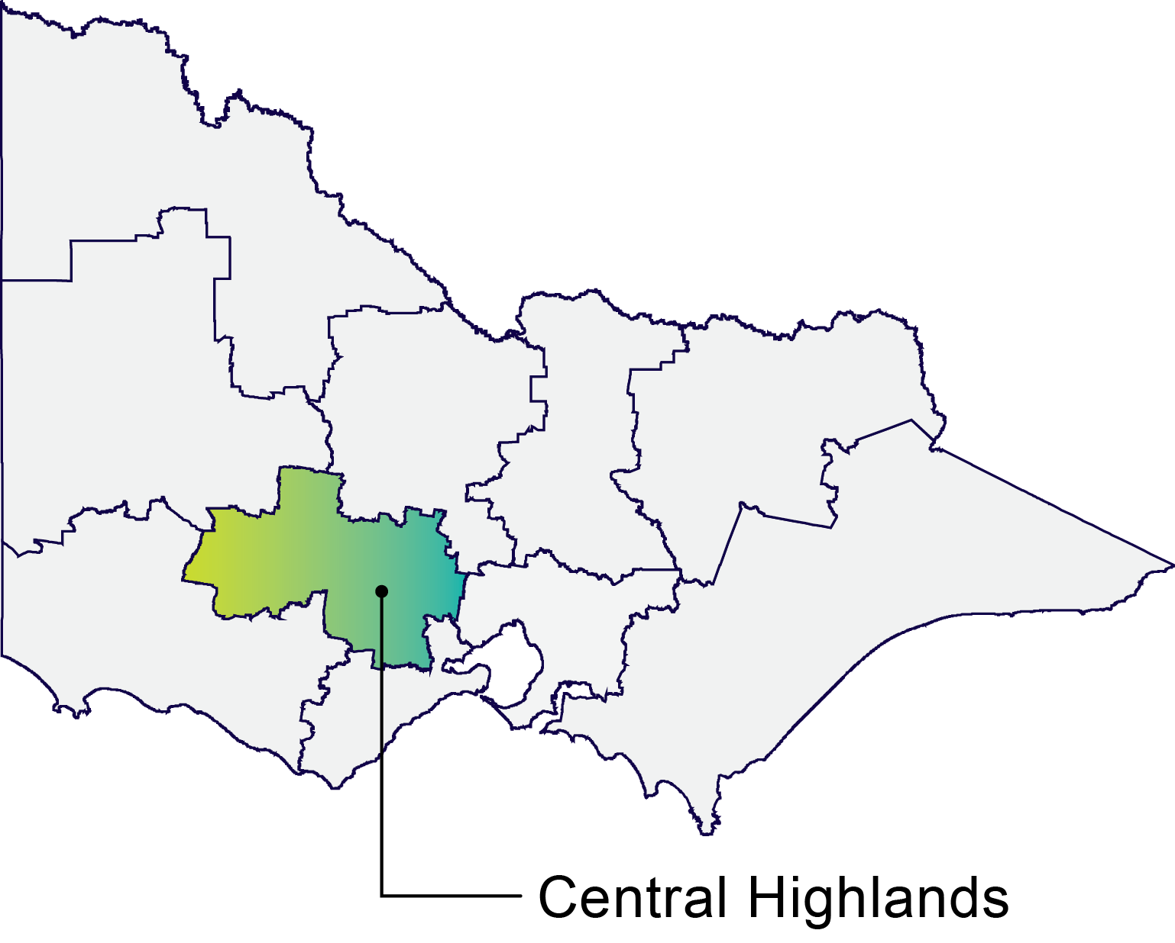

**Minimum and maximum daily temperatures** will continue to increase until at least 2050. Warming is projected to continue in the second half of the century if significant cuts in global greenhouse emissions are not made immediately (*very high confidence)*.

Compared to 1986–2005 baseline the projections indicate the following increase in **average annual temperature** (°C change):

Low emissions scenario:

* 1.0 (0.4–1.4) by 2050

1.0 (0.4–1.5) by 2090

High emissions scenario:

* 1.4 (0.8–1.8) by 2050

3.0 (2.1–3.5) by 2090

**Hot days and nights** will become hotter and more frequent, with longer, more intense heatwaves (*very high confidence*).

**Rainfall** will continue to be variable over time, but over the long term is expected to continue declining in the cool season (*medium to high confidence*). Long-term changes to summer rainfall are uncertain.

**Extreme rainfall** events are expected to become more intense on average through the century (*high confidence*) but remain very variable in space and time.

High-impact **climate hazards** that affect Victoria including floods, heatwaves, drought and bushfires are also changing.

# About these projections

The climate is changing globally and in Victoria. Further changes in climate are expected in the future, driven by ongoing emissions of greenhouse gasses globally.

This report presents projections of future changes to the climate of Central Highlands, providing a regional snapshot of the Victorian Climate Projections 2024 (VCP24). It complements previous projections, such as the Victorian Climate Projections 2019 (VCP19) and projections data available through [Victoria’s Future Climate Tool](https://vicfutureclimatetool.indraweb.io/).

The focus of this regional summary is on results from new regional climate model simulations:

* Australia-wide climate modelling prepared as part of the Australian Climate Service and the Coordinated Regional Climate Downscaling Experiment (CORDEX) (~10–17 km resolution)

Higher (~4 km) resolution modelling covering southeast Australia from the New South Wales and Australian Regional Climate Modelling Project phase 2.0 (NARCliM2.0).

These regional ‘downscaling’ simulations add detail to the latest generation of global climate modelling, used in the IPCC’s Sixth Assessment Report (AR6) – the Coupled Model Intercomparison Project Phase 6 (CMIP6).

Since the future global greenhouse gas emissions are unknowable, results are shown for two plausible but very different scenarios of future global emissions:

* a **low emissions scenario** (‘SSP1–2.6’) with immediate significant cuts in emissions to reach net zero around 2075, roughly compliant with the Paris Agreement

a **high emissions scenario** (‘SSP3–7.0’) under which emissions continue to increase and reach roughly double present levels by 2100.

These scenarios span a plausible range of change, but do not include the medium (‘RCP4.5’) and very high (‘RCP8.5’) emissions scenario used in VCP19 and available in the [Central Highlands Climate Projections 2019](https://www.climatechange.vic.gov.au/victorias-changing-climate/Central-Highlands-Climate-Projections-2019_20200219.pdf) (Clarke et al, 2019).

Additional relevant studies are explored where they have been produced. For more information on the climate modelling and emissions scenarios, refer to [Victoria’s Climate Science Report 2024](https://www.climatechange.vic.gov.au/victorias-changing-climate) (VCSR24) (DEECA, 2024) and the [Victorian Climate Projections 2024 Technical Report](https://www.climatechange.vic.gov.au/victorias-changing-climate) (VCP24 TR) (CSIRO, 2024).

For more information on sea-level rise (SLR) see the [Updated Sea-level Projections for Victoria](https://www.climatechange.vic.gov.au/victorias-changing-climate) (McInnes & Zhang, 2024). The SLR projections go to 2120 and include additional emissions scenarios as outlined below.

# Central Highlands climate will continue to get warmer

**Central Highlands has warmed since the 19th century and is projected to get warmer under all emissions scenarios, but much warmer under the high emissions scenario.**

Victoria’s temperature has increased by approximately 1.2 °C since standardised observational temperature records began in 1910 (Figure 1), with more than half of this warming occurring in the past 3 decades. The Central Highlands region has warmed by a similar amount between the start of records and 2011–2020. The last three years (2021–2023) have been cooler relative to the preceding decade but were still well above the long-term average.

Figure 1: Annual average temperature anomalies across Victoria 1910–2023

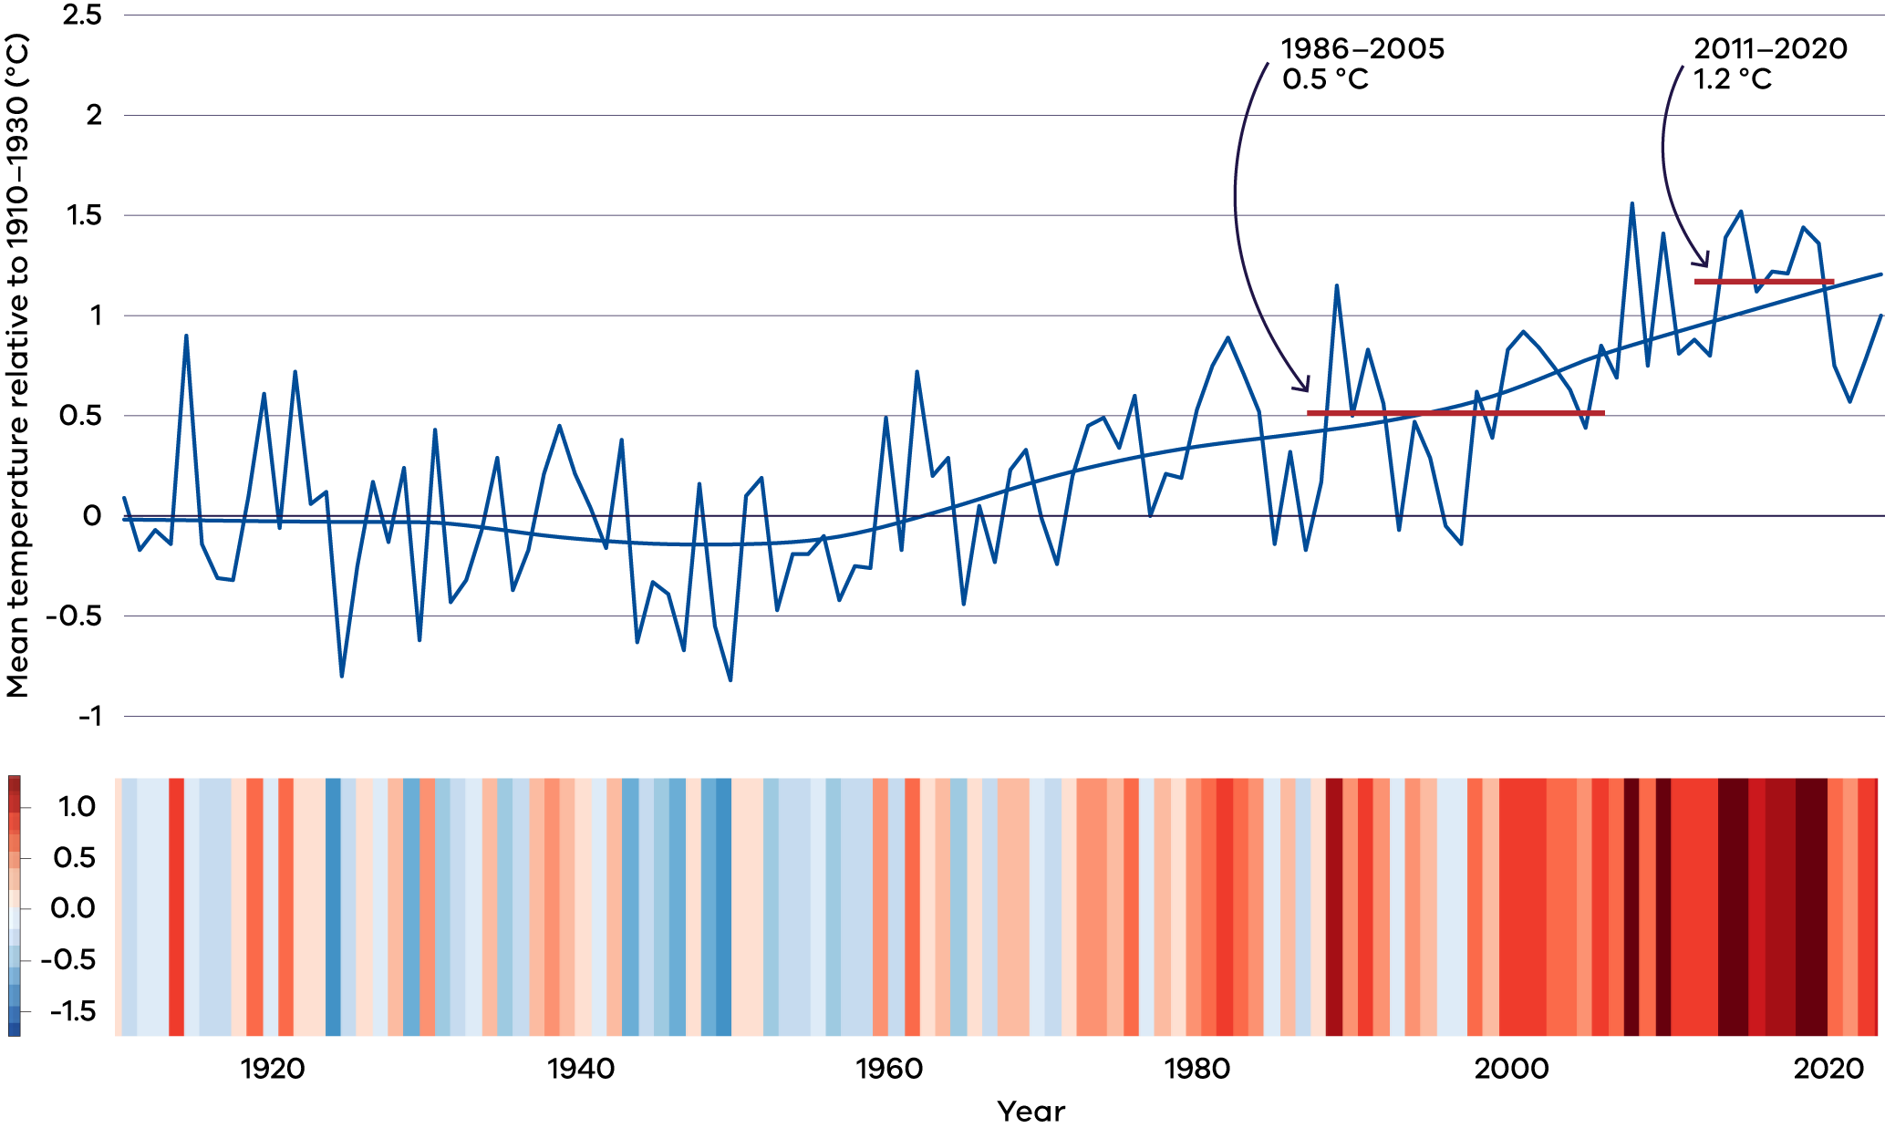

**Figure 1. Observed average annual temperature over Victoria, relative to the first 20 years of observations (1910–1930).** Data from ACORN-SAT.

As long as the concentration of greenhouse gases in the atmosphere continues to increase, this warming is expected to continue (*very high confidence*). However, as Figure 2 shows, the amount of warming in the second half of the century depends on the world’s greenhouse gas emissions over the coming decades.

Under the low emissions scenario, the average temperature will likely continue to rise until around 2050 before stabilising. The new regional climate model simulations project that the Central Highlands region will likely be 1.1 °C (0.4–1.4 °C [The presented likely range of change represents 80% of the models, that is excluding the highest and lowest 10% of simulations.]) warmer by 2050 and 1.0 °C (0.4–1.5 °C) warmer by 2090 under the low emissions scenario, compared to a 1986–2005 baseline.

Under the high emissions scenario, warming will continue throughout the 21st century, with average temperatures likely to be 1.4 °C (0.8–1.8 °C) warmer by 2050 and 3.0 °C (2.1–3.5 °C) warmer by 2090, compared to a 1986–2005 baseline.

Some of the climate model simulations project especially rapid warming in response to future greenhouse gas increases. The hottest of these ‘low-likelihood, high-warming’ simulations projects that average temperatures in the Central Highlands region could be   
5 °C hotter by 2090, compared to a 1986–2005 baseline. This level of warming is not considered to be likely, but it cannot be ruled out.

Figure 2: Change in average temperature for Central Highlands

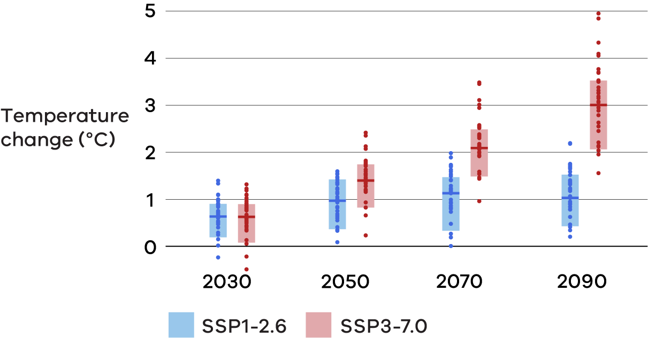

**Figure 2. Projected changes in annual mean temperature over the Central Highlands region, for low emissions (blue) and high emissions (red) relative to a 1986–2005 baseline, for four future time periods.** Data sourced from Australia-wide and NARCliM2.0 ~4 km climate modelling. See guidance on interpreting this figure at the back of the report.

# Heat extremes in Central Highlands region will continue to become hotter and more frequent

**As warming continues, we expect to experience more frequent hot days, hotter temperatures and longer, more frequent and more intense heatwaves.**

Ballarat experienced an average of 6.6 hot days (above 35.4 °C) per year from 2003–2022, up from an average of 3–4 per year from 1986–2005 (Table 1). (‘Hot days’ defined as days above the 99th percentile maximum daily temperature (occurring on average 3–4 times per year) in the historical baseline climate.) The number of very hot days (above 38.6 °C) has increased more dramatically over the same period, from 4 to 22 per decade. (‘Very hot days’ defined as days above the 99.9th percentile maximum daily temperature (occurring on average 3–4 times per decade) in the historical baseline climate.)

**Hot days** are expected to continue to become more frequent over the region. By 2050, the NARCliM2.0 ~4 km climate modelling projects that hot days could occur on average roughly three times as often under the high emissions scenario, or more than 4 times as often according to ‘low-likelihood high-warming’ models. By 2090, under the high emissions scenario, hot days could occur almost 5 times as often. The frequency of very hot days is projected to increase even more, for example roughly 10 times as often by 2090 under the high emissions scenario.

Table 1: Observed and projected average number of hot days and very hot days

**Hot days per year (35.4 °C for Ballarat)**

| 1986–2005  observed | 2003–2022  observed | 2040–2059  high emissions | 2090  high emissions |
| --- | --- | --- | --- |
| 3.7 | 6.6 | 4–11 (16*) | 7–15 (22*) |

**Very hot days per decade (38.6 °C for Ballarat)**

| 1986–2005  observed | 2003–2022  observed | 2040–2059  high emissions | 2090  high emissions |
| --- | --- | --- | --- |
| 4 | 22 | 0.7–19 (72*) | 7–52 (116*) |

**Table 1. The historical observed average number of hot days (35.4 °C) per year and very hot days (38.6 °C) per decade at Ballarat for 1986–2005 and 2003–2022, and projected future number of days for 2050 (2040–2059) and 2090 (2080–2099) under a high emissions scenario.** Data sourced from the Australian Gridded Climate Dataset (AGCD) for observed temperature and from NARCliM2.0 ~4 km climate simulations for future projections, with low-likelihood high-warming projections noted additionally with *.

Heat extremes are expected to become hotter in a warming climate (Figure 3). Temperature extremes are projected to warm more than average temperatures.

Under a high emissions scenario, the new regional climate model simulations project that very hot days will become 0.7–2.4 °C hotter by 2050, and 1.2–4.2 °C hotter by 2090 (Figure 3). This means that what was previously a 41 °C day could be closer to 43 °C by 2050 or 45 °C by 2090.

Importantly, hot minimum temperatures (for example hot night-time temperatures) are also expected to get hotter.

Figure 3: Change in very hot day temperature for Central Highlands

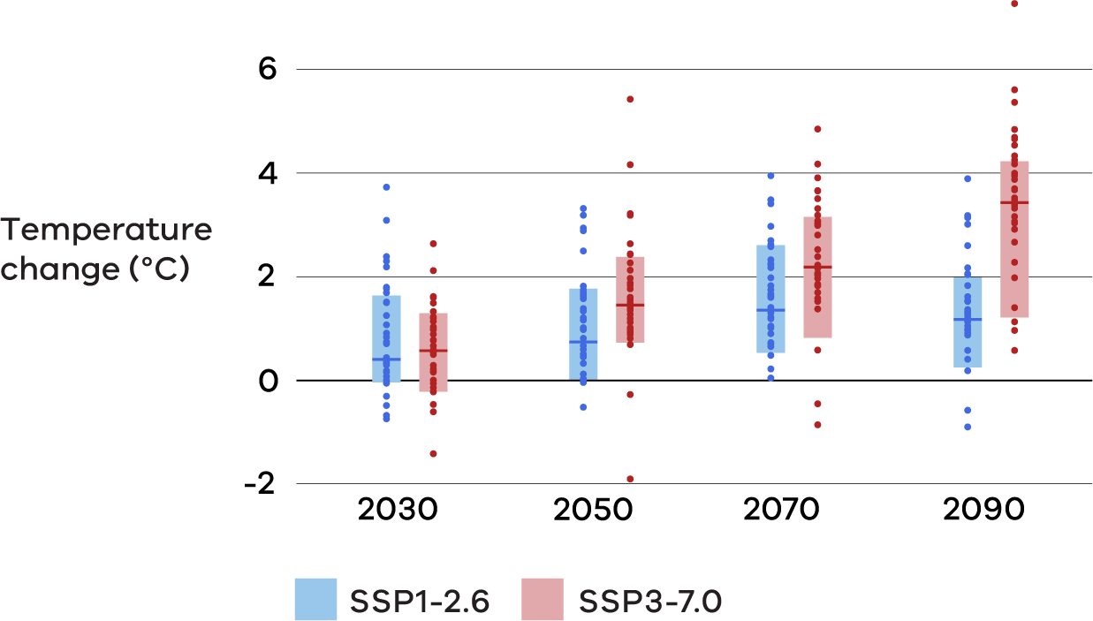

**Figure 3. Projected changes in the temperature of very hot days (99.9th percentile) over the Central Highlands for low emissions (blue) and high emissions (red) relative to a 1986–2005 baseline, for four future time periods.** Data sourced from Australia-wide and NARCliM2.0 ~4 km climate modelling. See guidance on interpreting this figure at the back of the report.

**Heatwaves** are prolonged periods of excessive heat that generally last for at least three or more successive days. Since the 1950s the intensity, frequency and duration of heatwaves in Victoria have increased, and the typical Victorian heatwave season has become longer. The observed trends have accelerated over the past few decades and are projected to continue in the future. Projected changes in heatwaves are larger for the high emissions scenario than for the low emissions scenario.

Chapter 4 of VCSR24 provides more information on heatwave and extreme heat hazards in Victoria.

# Rainfall across Central Highlands region will continue to change

**A warmer climate will influence rainfall patterns and the total amount of rainfall that the Central Highlands region receives. While it is likely that the Central Highlands region will receive less rainfall in the cool season, projections for summer rainfall are less clear. Rainfall will continue to be highly variable.**

Victoria’s rainfall varies greatly from year to year and decade to decade and will continue to be very variable over time. However, underlying this variability, there has been a decline in average rainfall between 1961–1990 and more recent decades, especially in the cool season. Cool season rainfall over the Central Highlands region declined roughly 10% between 1961–1990 and 2004–2023 (Figure 4). This is despite some individual relatively wet cool seasons since 2004 and consecutive wet cool seasons in 2020, 2021 and 2022.

Figure 4: Annual cool season rainfall (Apr–Oct) for Central Highlands

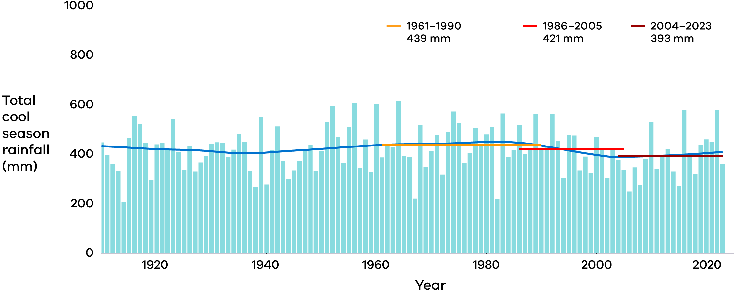

**Figure 4. Observed cool season rainfall for the Central Highlands from 1910–2023.** The blue line shows the long-term trend. Average rainfall is also shown for a number or time periods: the BOMs 1961–1990 baseline, the 1986–2005 baseline used for the projections in this report and the most recent 20 years 2004–2023. Data sourced from the Australian Gridded Climate Dataset (AGCD).

**Cool season rainfall** is projected to continue to decline over the Central Highlands region (*medium to high confidence*). The new regional climate model simulations are most consistent in projecting significant rainfall decreases in spring. For winter, projected decreases are smaller and a significant number of simulations project increases. A wider range of possible changes, including both increases and decreases, are projected for Autumn (Figure 5).

For **summer rainfall**, the projections are less clear than for the other seasons, and the new climate modelling does not narrow the outlook. Although most of the simulations project a decline in rainfall, the range of results is large and includes increases and decreases in rainfall.

Planning for climate change should consider the full range of projected future climate scenarios, as well as the planning context (for example vulnerability and risk profile). In considering future water availability, it is also important to factor in other influences on the hydrological cycle, for example, the evaporation which is projected to increase as temperatures warm.

Changes in rainfall as a result of long-term trends will become larger and emerge from natural variability as the century progresses, particularly under the high emissions scenario.

According to previous climate projections, **drought** duration, intensity and the percentage of time spent in drought in south-east Australia are projected to increase. Consistent with this, the new NARCliM2.0 ~4 km climate modelling projects that dry months will become more frequent in Victoria. However, wet periods can still occur even during a drying trend, and some model simulations show increasing rainfall variability with larger swings between wet and dry.

Increasing temperature and evaporation are also expected to reduce water availability in the future, in addition to reduced rainfall and increases in dry periods.

Figure 5: Change in seasonal rainfall for Central Highlands (2050)

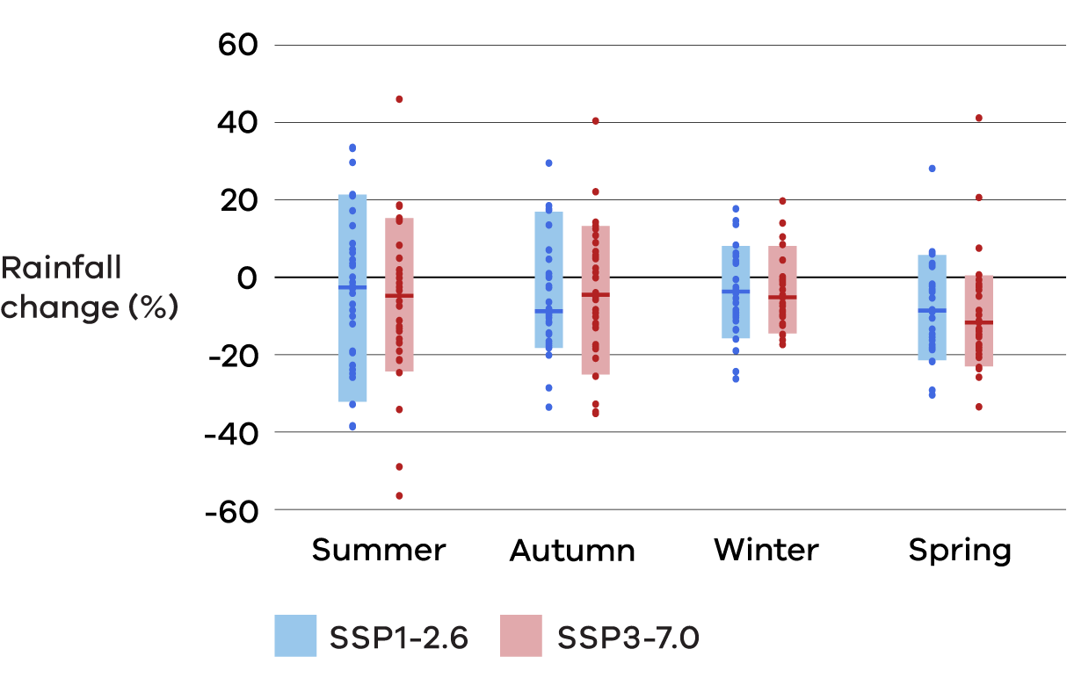

**Figure 5. Projected changes in seasonal rainfall for the Central Highlands for 2050 (2040–2059) for low (blue) and high (red) emissions scenarios, relative to a 1986–2005 baseline.** Data sourced from Australia-wide and NARCliM2.0 ~4 km climate modelling. See guidance on interpreting this figure at the back of the report.

Chapter 4 of VCSR24 provides more information on drought hazards in Victoria.

# Extreme rainfall events are expected to intensify

**A warming of the climate is expected to make heavy rainfall events more intense, with shorter-duration rainfall events intensifying more than longer-duration events.**

Work undertaken as part of an update to the Australian Rainfall and Runoff (ARR) guideline (see: Wasko et al. 2024) suggests that, broadly, across the whole of Australia, daily rainfall extremes may increase by approximately 8% per degree of global warming while shorter sub-daily rainfall extremes may increase by approximately 15% per degree of global warming.

The new regional climate model simulations for Victoria indicate a range of possible changes in the amount of rain on **very heavy rainfall days** with a tendency towards an increase in all seasons (Figure 6). (‘Very heavy’ rainfall days are defined as days with rainfall amounts above the 99.9th percentile (average 3–4 times per decade) daily maximum rainfall over the 1986–2005 baseline period.) For 2050, the multimodel median across all of the simulations shows that ‘very heavy’ rainfall days could have 5–15% more rainfall, while the upper end of the projected likely range shows increases of more than 30–70% depending on the season and emissions scenario.

Given the multimodel range for regional projections, the ARR guidance to scale extreme rainfall by warming per degree global warming, with a higher value for sub-daily rainfall than daily, is deemed a suitable starting point.

Figure 6: Change in very heavy daily rainfall for Central Highlands (2050)

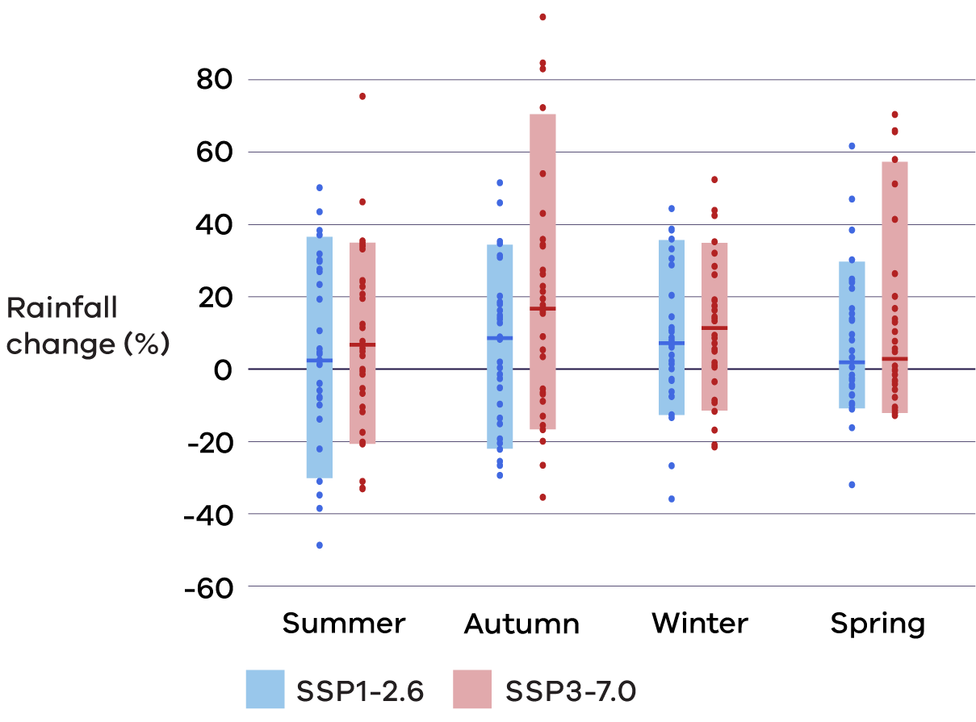

**Figure 6. Projected changes on very heavy rainfall days (99.9th percentile) for the Central Highlands, by season for 2050 (2040–2059) under low (blue) and high (red) emissions scenarios, relative to a 1986–2005 baseline.** Data sourced from Australia-wide and NARCliM2.0 ~4 km climate modelling. See guidance on interpreting this figure at the back of the report.

# Victoria is likely to experience fewer frosts

In a warming climate, frosts are expected to become less frequent over time. However, it is possible for there to be an increased risk of damaging spring frost in some regions when cold clear nights persist longer than is suggested by the projected change in minimum temperature, and changes to seasonality and flowering mean crops are more vulnerable (see chapter 4 of VCP24 TR). Over time the effect of increasing minimum temperatures is expected to gradually overpower the other effects and lead to a decrease in frost risk in almost all regions and seasons.

The new VCP24 projections do not contain any new frost modelling. However, the previous VCP19 projections indicated a decrease in the number of days with minimum temperatures below 0 °C in the Central Highlands region.

# Victoria is likely to experience an increase in fire weather

The occurrence of major bushfires requires sufficient fuel that is dry enough to burn, weather conditions favourable to bushfire spread and an ignition source. Climate change is increasing the occurrence of fire weather and fuel dryness, but its effects on fuel load and ignition sources are more complex and less well understood.

There is growing evidence that fire weather conditions are worsening in south-east Australia. In addition, fire seasons have become longer and are starting earlier in the year. These trends are likely to continue, in particular under projections of decreasing rainfall and increasing temperatures. The scale of future changes is dependent on future greenhouse gas emissions.

Chapter 4 of VCSR24 provides more information on bushfire hazards in Victoria.

# Flooding patterns in Victoria are likely to change

Victoria has experienced a trend of small floods becoming smaller and large floods becoming larger, and these trends are projected to continue at a greater rate in the future. Flood risk in Victoria is likely to double by the end of the century if greenhouse gas emissions continue to rise at a medium to high rate. That is, a flood with a 1 in 100 chance of being exceeded now might be twice as likely by the end of this century.

Chapter 4 of VCSR24 provides more information on flood hazards in Victoria.

# Table of projected changes in key climate variables

Table 2: Projected changes in key climate variables for Central Highlands

| Projected changes for the Central Highlands region | 2050 | | 2070 | | 2090 | |
| --- | --- | --- | --- | --- | --- | --- |
| Low emissions (SSP1–2.6) | High emissions (SSP3–7.0) | Low emissions (SSP1–2.6) | High emissions (SSP3–7.0) | Low emissions (SSP1–2.6) | High emissions (SSP3–7.0) |
| **Average temperatures (°C change)** | | | | | | |
| Average temperature, annual | 1.0 (0.4 to 1.4) | 1.4 (0.8 to 1.8) *2.4 | 1.1 (0.3 to 1.5) | 2.1 (1.5 to 2.5) *3.5 | 1.0 (0.4 to 1.5) | 3.0 (2.1 to 3.5) *5.0 |
| Average minimum temperature, annual | 0.9 (0.3 to 1.3) | 1.3 (0.8 to 1.6) *2.2 | 1.0 (0.2 to 1.4) | 2.0 (1.4 to 2.4) *3.3 | 0.9 (0.3 to 1.5) | 2.7 (1.9 to 3.5) *4.8 |
| Average maximum temperature, annual | 1.1 (0.5 to 1.6) | 1.6 (1.0 to 2.1) *2.7 | 1.2 (0.6 to 1.6) | 2.4 (1.7 to 2.8) *3.7 | 1.2 (0.7 to 1.7) | 3.4 (2.3 to 3.8) *5.2 |
| **Change (°C change) in temperature of hot days (99th percentile, occurring roughly 3–4 times per year)** | | | | | | |
| 99th percentile hot days, annual (°C) | 1.1 (0.2 to 2.0) | 1.8 (0.7 to 2.5) | 1.5 (0.4 to 2.0) | 2.2 (1.6 to 3.3) | 1.1 (0.4 to 1.9) | 3.4 (2.2 to 4.3) |
| **Change (°C change) in very hot days (99.9th percentile, occurring roughly 3–4 times per decade)** | | | | | | |
| 99.9th percentile hot days, annual (°C) | 0.7 (0.0 to 1.8) | 1.4 (0.7 to 2.4) | 1.3 (0.5 to 2.6) | 2.2 (0.8 to 3.1) | 1.2 (0.2 to 2.0) | 3.4 (1.2 to 4.2) |
| **Change (% change) in average seasonal rainfall** | | | | | | |
| Annual rainfall (%) | -9 (-19 to 7) | -7 (-16 to 5) | -6 (-18 to 6) | -11 (-19 to 11) | -6 (-17 to 6) | -15 (-29 to 11) |
| Summer rainfall (%) | -3 (-32 to 21) | -5 (-24 to 15) | -9 (-32 to 7) | 3 (-32 to 26) | -1 (-23 to 15) | -1 (-37 to 37) |
| Autumn rainfall (%) | -9 (-18 to 17) | -4 (-25 to 13) | -2 (-16 to 18) | -8 (-29 to 16) | -7 (-19 to 12) | -15 (-34 to 19) |
| Winter rainfall (%) | -4 (-16 to 8) | -5 (-14 to 8) | -5 (-16 to 7) | -8 (-22 to 6) | -4 (-14 to 7) | -15 (-24 to 0) |
| Spring rainfall (%) | -9 (-21 to 6) | -12 (-23 to 1) | -7 (-21 to 12) | -13 (-33 to 8) | -12 (-29 to 15) | -21 (-39 to 7) |

**Table 2. Projected changes in key climate variables for Central Highlands.** Values come from the combined set of Australia-wide and NARCliM2.0 ~4 km regional climate model simulations and show the median and 10th to 90th percentile range in brackets. Changes are calculated from the 1986–2005 baseline to 2050 (2040–2059), 2070 (2060–2079) and 2090 (2080–2099). For temperature variables, the low-likelihood, high-warming models have been excluded from the median and range (see chapter 2 of the VCP24 TR) but are indicated separately with * for the high emissions scenario.

# Interpreting the projections figures

Figure 2: Projected change in mean annual temperature, Central Highlands



* Projected changes are calculated from a 1986–2005 baseline to future 20-year periods, labelled by the central year (for example, ‘2050’ represents 2040–2059).
* The coloured vertical bars show the 10th to 90th percentile range from the combined set of Australia-wide and NARCliM2.0 ~4 km climate model simulations (totalling 33 different simulations). This ‘likely’ range encompasses 80% of the model results and excludes model results which are in the top or bottom 10%. For temperature, it also excludes ‘low-likelihood, high-warming’ simulations from models with climate sensitivity outside the expected range (ECS > 4.5 °C, see chapter 2 of VCP24 TR for more detail).
* The dark horizontal line shows the median of the model results (excluding ‘low-likelihood, high-warming models’ for temperature).
* Each individual model result is shown by the small dots.

## References:

CSIRO. (2024). [*Victoria’s Climate Projections 2024 Technical Report*](https://www.climatechange.vic.gov.au/victorias-changing-climate) – for in-depth description and analysis of the climate model projections as well as further technical references.

DEECA. (2024). [*Victoria’s Climate Science Report 2024*](https://www.climatechange.vic.gov.au/victorias-changing-climate) – for an up-to-date synthesis of observed and projected future climate changes for the state of Victoria and more information on climate hazards.

McInnes, K. L., & Zhang, X. (2024). [*Updated Sea-level Projections for Victoria*](https://www.climatechange.vic.gov.au/victorias-changing-climate). CSIRO Environment report for Department Environment, Energy and Climate Action, Victoria, – provides the latest science relating to sea level from the IPCC’s sixth assessment report.

Wasko, C., Westra, S., Nathan, R., Pepler, A., Raupach, T. H., Dowdy, A., Johnson, F., Ho, M., McInnes, K. L., Jakob, D., Evans, J., Villarini, G., and Fowler, H. J. (2024). [A systematic review of climate change science relevant to Australian design flood estimation](https://doi.org/10.5194/hess-28-1251-2024), *Hydrology and Earth Systems Sciences*, 28(5), 1251–1285.

## Other resources:

For other information and resources relating to VCSR24 refer to DEECA’s website [Victoria’s changing climate: Understanding Victoria's past and future climate](https://www.climatechange.vic.gov.au/victorias-changing-climate). This includes:

* Clarke, J.M., Grose, M., Thatcher., M., Round, V., & Heady, C. (2019). [*Central Highlands Climate Projections 2019*](https://www.climatechange.vic.gov.au/victorias-changing-climate/Central-Highlands-Climate-Projections-2019_20200219.pdf). CSIRO.
* [Factsheet 1 – How do the Victorian Climate Projections 2024 compare with previous climate projections for Victoria?](https://www.climatechange.vic.gov.au/victorias-changing-climate/VCSR24-Factsheet-1-Comparison-VCP24-and-VCP19.pdf)
* [Factsheet 2 – What do the Victorian Climate Projections 2024 say about changes in rainfall?](https://www.climatechange.vic.gov.au/victorias-changing-climate/VCSR24-Fact-sheet-2-Changes-in-rainfall.pdf)
* [Factsheet 3 – Using the Victorian Climate Projections 2024](https://www.climatechange.vic.gov.au/victorias-changing-climate/VCSR24-Fact-Sheet-3-Using-VCP24.pdf)
* [Factsheet 4 – Unmodelled futures and the Victorian Climate Projections 2024](https://www.climatechange.vic.gov.au/__data/assets/pdf_file/0027/732627/Factsheet-4-Unmodelled-futures-and-the-Victorian-Climate-Projections-2024.pdf)
* [Victoria’s Future Climate Tool](https://vicfutureclimatetool.indraweb.io/)

# Publication information

## Acknowledgements

We acknowledge Victorian Traditional Owners and their Elders past and present as the original custodians of Victoria’s land and waters and commit to genuinely partnering with them and Victoria’s Aboriginal community to progress their aspirations.

## Copyright

© The State of Victoria Department of Energy, Environment and Climate Action January 2025

## Creative Commons

This work is licensed under a Creative Commons Attribution 4.0 International licence, visit the [Creative Commons website](http://creativecommons.org/licenses/by/4.0/) (<http://creativecommons.org/licenses/by/4.0/>).

You are free to re-use the work under that licence, on the condition that you credit the State of Victoria as author. The licence does not apply to any images, photographs or branding, including the Victorian Coat of Arms, and the Victorian Government and Department logos.

**ISBN** 978-1-76176-006-8 **(pdf/online/MS word)**

Citation: CSIRO & Department of Energy, Environment and Climate Action (DEECA). (2024). *Central Highlands Climate Projections 2024*. <https://www.climatechange.vic.gov.au/victorias-changing-climate>

This report should be read in conjunction with the Victorian Climate Projections 2024 Technical Report, Victoria’s Climate Science Report 2024, and Updated Sea-level Projections for Victoria 2024.

## Disclaimer

CSIRO and the State of Victoria advise that the information contained in this publication comprises general statements based on scientific research.

The reader is advised and needs to be aware that such information may be incomplete or unable to be used in any specific situation. No reliance or actions must therefore be made on that information without seeking prior expert professional, scientific and technical advice. To the extent permitted by law, CSIRO (including its employees and consultants) excludes all liability to any person for any consequences, including but not limited to all losses, damages, costs, expenses and any other compensation, arising directly or indirectly from using this publication (in part or in whole) and any information or material contained in it.

## Accessibility

To receive this document in an alternative format, phone the Customer Service Centre on 136 186, email [customer.service@delwp.vic.gov.au](mailto:customer.service@delwp.vic.gov.au), or contact National Relay Service on 133 677. Available at DEECA website ([www.deeca.vic.gov.au](http://www.deeca.vic.gov.au/)).

**End of document.**